
DEVELOPMENT OF AN SMS-BASED APPLICATION FOR TRACKING COUNTERFEIT PRODUCTS IN KENYA
SUMEYA HASSAN MOHAMED
BSCS/2024/52117

A project submitted in partial fulfilment of the requirements for the award of the degree of Bachelor of Science in Computer Science
Faculty of Computer Science
Umma University
Kajiado, Kenya
November 2026

This thesis is available for library use on the understanding that it is copyright material and that no quotation from the thesis may be published without proper acknowledgment.

DECLARATION
I, SUMEYA HASSAN MOHAMED, declare that this project report is my original work and that it has not previously been presented for the award of a degree at this or any other university or institution. Where the work of other people has been used, it has been duly acknowledged.
Student’s signature:
Name: …………………………………………… Signature: ……………………………
Date: ……………………………

This project has been submitted for examination with my approval as the university supervisor.
Supervisor’s signature:
Signature: …………………………… Date: ……………………………
Mr. Alianda
Umma University, Kenya

DEDICATION
I dedicate this work to my family, whose patience, encouragement and support carried me through my studies, and to everyone who works to protect Kenyan consumers from counterfeit goods.

ACKNOWLEDGEMENT
I sincerely thank my parents for their love, sacrifices, prayers and constant encouragement throughout my studies and throughout the development of this project. Their support gave me the strength to keep going, and this achievement would not have been possible without them.

ABSTRACT
Counterfeit goods threaten public health, consumer safety, legitimate businesses and government revenue in Kenya, yet ordinary buyers have few practical ways of confirming what they buy: holograms and labels are easily imitated, inspection depends on officials being present, and app-based tools exclude people without smartphones or internet access. This project presents Halisi Verify, an SMS-based counterfeit product verification and tracking system for the Kenyan market. Manufacturers register production batches and the system generates a unique, random nine-digit code for every unit; a customer sends the code by SMS (for example “VERIFY 839274615”) and immediately receives a reply stating whether the product is genuine, suspicious, invalid or deactivated. Every check is recorded, a code checked more often than a configurable threshold is flagged as suspicious because a copied code is a strong sign of counterfeit packaging, and customers can report suspected fakes by SMS. A web-based Manufacturer App and Admin Dashboard support the management of products, batches and codes and the monitoring of suspicious codes, reports and geographic hotspots. The system was built with React, TypeScript, Supabase and Africa’s Talking and deployed on Vercel. Automated database tests, endpoint tests, interface checks and user acceptance testing with five participants confirmed that the core verification logic, access control and interfaces work as intended, showing that SMS can give every mobile phone user a simple way to verify products while giving manufacturers and regulators timely data for tracking counterfeiting.
Key words: Counterfeit products, Product authentication, SMS verification, Unique codes, Anti-counterfeiting, Supabase, React.

TABLE OF CONTENTS

DECLARATION i
DEDICATION ii
ACKNOWLEDGEMENT iii
ABSTRACT iv
CHAPTER 1: INTRODUCTION 1
1.1 Background of the Study 1
1.2 Problem Statement 2
1.3 Objectives 2
1.3.1 General Objective 2
1.3.2 Specific Objectives 2
1.4 Research Questions 3
1.5 Justification 3
1.6 Scope of the Project 3
1.7 Limitations 4
1.8 Summary 4
CHAPTER 2: LITERATURE REVIEW 5
2.1 Introduction 5
2.2 Challenges in Traditional Counterfeit Detection and Product Verification 5
2.2.1 Limited Means for Consumers to Verify Products 5
2.2.2 Weaknesses of Physical Security Features and Manual Inspection 5
2.2.3 Regulatory, Logistical and Communication Barriers 6
2.3 Review of Existing Systems Related to Product Verification 6
2.3.1 mPedigree (Goldkeys) 6
2.3.2 Sproxil Mobile Authentication Service 7
2.3.3 KRA Excisable Goods Management System and Soma Label App 8
2.3.4 KEBS Standardization Mark SMS Verification 9
2.3.5 Comparison of Reviewed Systems 10
2.3.6 Usability, Accessibility and Functional Limitations 10
2.3.7 Identified Gaps from Reviewed Systems 11
2.4 Concepts and Technologies Underpinning Code-Based Product Verification 11
2.4.1 Mass Serialisation and Unique Product Codes 11
2.4.2 SMS as a Verification Channel 12
2.4.3 Detection of Cloned Codes 12
2.4.4 Cloud Databases, Access Control and Data Protection 12
2.4.5 Evaluation of Verification Systems 12
2.5 Summary 13
CHAPTER 3: SYSTEM DEVELOPMENT METHODOLOGY 14
3.1 Introduction 14
3.2 Methodological Approach 14
3.3 Agile Development Phases 14
3.3.1 Requirements Phase 15
3.3.2 Design Phase 15
3.3.3 Development Phase 15
3.3.4 Testing Phase 15
3.3.5 Deployment Phase 16
3.3.6 Review Phase 16
3.4 Summary 16
CHAPTER 4: REQUIREMENTS GATHERING AND ANALYSIS 17
4.1 Introduction 17
4.2 Data Collection Approach 17
4.3 Data Collection Methods 17
4.4 Primary Data Collection 18
4.5 Data Analysis 19
4.5.1 Interview Data Summary 19
4.5.2 Questionnaire Analysis 20
4.6 Secondary Data Collection 30
4.7 Stakeholders Identification 31
4.8 Challenges in Requirements Gathering and Analysis 31
4.9 Summary 32
CHAPTER 5: SYSTEM DESIGN 33
5.1 Introduction 33
5.2 Structural Diagrams 33
5.2.1 Class Diagram 33
5.2.2 Object Diagram 34
5.2.3 Component Diagram 35
5.3 Behavioral Diagrams 36
5.3.1 Use Case Diagram 36
5.3.2 Sequence Diagram 37
5.3.3 Activity Diagram 38
5.4 Database Schema 39
5.4.1 Entity Relationship Diagram (ERD) 40
5.4.2 Physical Database Schema 41
5.5 Wireframes 42
5.6 Summary 43
CHAPTER 6: SYSTEM DEVELOPMENT AND IMPLEMENTATION 44
6.1 Introduction 44
6.2 System Development Tools and Techniques 44
6.2.1 Integrated Development Environment (IDE) 44
6.2.2 Front-end Development 45
6.2.3 Database Management Tools 45
6.3 System Interfaces 46
6.4 Challenges Encountered During Development 54
6.4.1 Technical Complexities 54
6.4.2 User Adoption and Resistance 55
6.4.3 Economic Constraints 55
6.4.4 Continuous Updates and Support 55
6.5 Summary 55
CHAPTER 7: SYSTEM TESTING AND DEPLOYMENT 56
7.1 Introduction 56
7.2 System Testing and Validation 56
7.2.1 Unit Tests 56
7.2.2 Functional Testing 57
7.2.3 User Interface (UI) Testing 57
7.3 Testing Results 58
7.4 System Deployment 58
7.4.1 Current Deployment Methods 58
7.4.2 Future Deployment Plans 59
7.5 Summary 59
CHAPTER 8: DISCUSSIONS, FUTURE WORKS AND RECOMMENDATIONS 60
8.1 Introduction 60
8.2 Discussions of Objectives 60
8.3 Future Work 61
8.3.1 Live SMS Shortcode 61
8.3.2 USSD and Voice Channels 61
8.3.3 Notifications to Manufacturers 61
8.3.4 Integration with Regulatory Systems 61
8.3.5 Improved Location Data and Analytics 61
8.4 Recommendations 61
8.4.1 Consumer Awareness 61
8.4.2 Secure Code Printing 61
8.4.3 Strengthening Data Security 62
8.4.4 Institutional Collaboration 62
8.4.5 Regular Maintenance 62
8.5 Summary 62
APPENDIX 63
A.1: User Survey Questionnaire 63
A.2: Work Plan and Schedule 65
A.3: Budget 65
A.4: Project Repository and Live System 66
A.5: Plagiarism Report 66
REFERENCES 68

LIST OF FIGURES

Figure 2.1 mPedigree Goldkeys Product Verification 7
Figure 2.2 Sproxil Mobile Authentication Service 8
Figure 2.3 KRA Excise Stamp Verification (Soma Label App) 9
Figure 2.4 KEBS Standardization Mark Verification by SMS 10
Figure 3.1 Agile Development Cycle 14
Figure 4.1 Methods Consumers Use to Check Products 20
Figure 4.2 Types of Mobile Phones Used by Respondents 21
Figure 4.3 Experience and Reporting of Counterfeit Products 22
Figure 4.4 Willingness to Verify Products by SMS 22
Figure 4.5 How Manufacturers Learn About Counterfeits 23
Figure 4.6 Willingness to Adopt Unique Product Codes 24
Figure 4.7 Information Most Useful to Manufacturers 25
Figure 4.8 Effect of Counterfeits on Manufacturers 26
Figure 4.9 Product Categories Most Often Counterfeited 27
Figure 4.10 Perceived Value of Central Verification Data 28
Figure 4.11 Frequency of Encountering Suspected Counterfeits 29
Figure 4.12 Most Practical Verification Channel for Consumers 30
Figure 5.1 Class Diagram 34
Figure 5.2 Object Diagram of a Suspicious Code 35
Figure 5.3 Component Diagram 36
Figure 5.4 Use Case Diagram 37
Figure 5.5 Sequence Diagram for SMS Verification 38
Figure 5.6 Activity Diagram 39
Figure 5.7 Entity Relationship Diagram 41
Figure 5.8 Wireframes of the Main Screens 43
Figure 6.1 Development Environment (Visual Studio Code) 45
Figure 6.2 Supabase Project Dashboard 46
Figure 6.3 Login Page 46
Figure 6.4 Manufacturer Registration Page 47
Figure 6.5 SMS Verification Simulator 48
Figure 6.6 Manufacturer Dashboard 49
Figure 6.7 Verification Codes Page 50
Figure 6.8 Admin Dashboard 51
Figure 6.9 Suspicious Activity Page 52
Figure 6.10 Counterfeit Reports Page 53
Figure 6.11 Verification Hotspots Page 53
Figure 6.12 Manufacturers Page 54
Figure A.1 Project Repository 66
Figure A.2 Plagiarism Report (DrillBit) 67

LIST OF TABLES

Table 2.1 Comparison of Existing Product Verification Systems 10
Table 3.1 Development Iterations 15
Table 4.1 Primary Data Collection 18
Table 4.2 Consumer Interview Summary 19
Table 4.3 Manufacturer Interview Summary 19
Table 4.4 Retailer and Regulator Interview Summary 20
Table 5.1 Main Classes of the System 34
Table 5.2 Database Tables 42
Table 5.3 SMS Verification Rules 42
Table 6.1 Development Tools and Technologies 44
Table 7.1 Unit Testing (selection of 32 automated tests) 57
Table 7.2 Functional Testing 57
Table 7.3 User Interface Testing 58
Table 7.4 Testing Results 58
Table A.1 Work Plan and Schedule 65
Table A.2 Budget 66

LIST OF ABBREVIATIONS
Abbreviation | Meaning
ACA | Anti-Counterfeit Authority
API | Application Programming Interface
CSV | Comma-Separated Values
EGMS | Excisable Goods Management System
ERD | Entity Relationship Diagram
IDE | Integrated Development Environment
KEBS | Kenya Bureau of Standards
KES | Kenya Shillings
KRA | Kenya Revenue Authority
OMG | Object Management Group
PIN | Personal Identification Number
QR | Quick Response (code)
RFID | Radio-Frequency Identification
RLS | Row-Level Security
RPC | Remote Procedure Call
S-Mark | Standardization Mark (KEBS)
SKU | Stock Keeping Unit
SMS | Short Message Service
SQL | Structured Query Language
UI | User Interface
UML | Unified Modeling Language
USSD | Unstructured Supplementary Service Data

CHAPTER ONE: INTRODUCTION

1.1 Background of the Study
Counterfeiting is the manufacture or sale of goods that imitate genuine branded products with the intention of deceiving buyers. In Kenya, counterfeit and substandard goods are found in many everyday categories, including medicines, cooking oil, soaps and detergents, beverages, electronics, cosmetics and agricultural inputs such as seeds and fertilisers (Anti-Counterfeit Authority, n.d.-b). The problem is not limited to lost profits for manufacturers. Fake medicines can fail to treat illness or cause harm, fake fertiliser can destroy a farmer’s harvest, and counterfeit food and cosmetics can expose families to dangerous substances.
Kenya has a legal and institutional framework for fighting counterfeits. The Anti-Counterfeit Act of 2008 established the Anti-Counterfeit Authority (ACA), which works alongside bodies such as the Kenya Bureau of Standards (KEBS) and the Kenya Revenue Authority (KRA) (Anti-Counterfeit Act, 2008; Anti-Counterfeit Authority, n.d.-a). However, enforcement depends heavily on inspections, raids and complaints, and officials cannot be present at every shop, market stall or kiosk where goods change hands. The final decision about whether a product is genuine is usually left to the buyer, who often has no reliable way of checking.
Manufacturers have tried to help buyers by adding security features such as holograms, tamper-evident seals, special inks and printed batch numbers. Counterfeiters have steadily learned to copy these features, and most buyers do not know what the genuine versions should look like. At the same time, mobile phone use in Kenya is very high, and SMS works on every mobile phone, including basic feature phones that cannot run apps or access the internet (Communications Authority of Kenya, 2025). By June 2025 Kenya had 76.7 million mobile subscriptions, a penetration rate of 146.3 percent, and about 29.5 million feature phones were in use (Communications Authority of Kenya, 2025). This makes SMS a practical channel for putting a verification tool into the hands of almost every consumer.
Unique product codes combined with SMS verification have been used in other African countries, particularly for pharmaceuticals (Rasheed et al., 2018; World Economic Forum, 2017). These initiatives show that consumers are willing to verify products when the process is quick and free. This project builds on that idea and adds a tracking layer: every check is recorded so that manufacturers and regulators can see where and how often codes are checked, detect codes that have been copied, and receive reports of suspected fakes directly from consumers.

1.2 Problem Statement
Consumers in Kenya do not have a simple, reliable and widely accessible way of confirming whether a product is genuine at the moment of purchase. Visual inspection of packaging is unreliable because counterfeiters copy labels, holograms and seals closely. Smartphone applications and QR-code tools exclude a large share of consumers who use basic phones or have limited internet access.
Manufacturers, on their side, have little visibility of what happens to their products after they leave the factory. They usually learn about counterfeits late, through complaints, falling sales or enforcement raids, and they cannot easily tell which markets or regions are most affected. Regulators face a similar information gap: reports of counterfeits are scattered, delayed and difficult to analyse.
As a result, counterfeit goods continue to circulate, consumers remain exposed to unsafe products, and genuine manufacturers lose revenue and trust. There is a need for a low-cost system that any mobile phone user can use to verify a product by SMS, and that at the same time records verification activity so that suspicious patterns, such as one code being checked many times in different places, can be detected and acted upon.

1.3 Objectives

1.3.1 General Objective
To develop an SMS-based application that enables consumers in Kenya to verify the authenticity of products using unique codes, and that enables manufacturers and administrators to track verification activity and detect counterfeit products.

1.3.2 Specific Objectives
- To assess the challenges consumers, manufacturers and regulators face in identifying and tracking counterfeit products in Kenya.
- To review existing product authentication and anti-counterfeiting systems and identify their limitations.
- To design and implement an SMS-based product verification and tracking system with a manufacturer application and an administrator dashboard, using React, Supabase and an SMS gateway.
- To test the functionality, security and usability of the developed system.

1.4 Research Questions
- What challenges do consumers, manufacturers and regulators face in identifying and tracking counterfeit products in Kenya?
- What are the strengths and limitations of existing product authentication and anti-counterfeiting systems?
- How can an SMS-based product verification and tracking system be designed and implemented using React, Supabase and an SMS gateway?
- How effectively does the developed system perform in terms of functionality, security and usability?

1.5 Justification
Counterfeiting affects nearly every household in Kenya, yet the tools available to ordinary buyers remain weak. A verification method based on SMS is justified because SMS is available on every mobile phone, needs no internet connection or app installation, and is already familiar to users through services such as mobile money. Giving each unit a unique, unpredictable code means that a counterfeiter who copies one code can be detected, because that code will be checked far more often than a genuine code normally would.
The project also benefits manufacturers and regulators. Every verification becomes a data point showing where and when a product was checked, and consumer reports arrive directly in a central system. This information supports faster investigations, targeted market inspections and better protection of brands. For the student, the project provides practical experience in requirements analysis, database design, secure web development, integration with telecommunication services, testing and deployment.

1.6 Scope of the Project
The project covers the design and development of a web-based system with three user groups. Manufacturers can register their company (subject to administrator approval), create product batches, obtain unique verification codes, export codes for printing, deactivate codes and monitor verification activity and reports for their own products. Administrators can approve and manage manufacturers, monitor all verifications, investigate and block suspicious codes, manage counterfeit reports, view verification hotspots and configure system rules. Customers verify products and report fakes by sending SMS messages, or through a public SMS simulator page.
The system is built with React and TypeScript on the front end, Supabase for the database, authentication and server functions, and Africa’s Talking as the SMS gateway. It targets products sold in Kenya and Kenyan mobile numbers. The project does not cover the physical printing of codes on packaging, integration with government databases, payment processing, USSD menus, or confirmation of counterfeits through laboratory testing.

1.7 Limitations
The system was developed as an academic project and therefore has some limitations. During development, the Africa’s Talking account could not be activated because the provider’s account verification email did not arrive, so live SMS replies to real phones could not be enabled; the SMS function was built and tested with messages in the provider’s format, and the demonstration uses a built-in SMS simulator that runs the same verification logic. The prototype limits each batch to 10,000 codes to stay within free-tier resources. The location of an SMS check is recorded only if the customer includes a town in the message or selects one in the simulator. The system relies on free hosting and database plans, which have usage limits. Finally, user acceptance testing was limited to five participants (three consumers and two retailers), who used the SMS simulator rather than live SMS messages.

1.8 Summary
This chapter introduced the problem of counterfeit products in Kenya and the difficulty consumers face in verifying goods at the point of purchase. It explained how weak verification tools, limited visibility for manufacturers and scattered information for regulators allow counterfeit goods to keep circulating. The chapter set out the general and specific objectives, research questions, justification, scope and limitations of a proposed SMS-based system that lets any mobile phone user verify a product with a unique code while giving manufacturers and administrators the data needed to detect and track counterfeiting.

CHAPTER TWO: LITERATURE REVIEW

2.1 Introduction
This chapter reviews existing knowledge and systems related to counterfeit products and product authentication. It first examines the challenges of traditional methods of detecting counterfeits. It then reviews four existing systems that are related to SMS-based product verification, namely mPedigree, Sproxil, the Kenya Revenue Authority excise stamp verification system and the Kenya Bureau of Standards (KEBS) Standardization Mark SMS check, compares their documented features and identifies their limitations. Finally, it reviews the concepts and technologies on which code-based product verification systems are built (Mackey & Nayyar, 2017; Rasheed et al., 2018).

2.2 Challenges in Traditional Counterfeit Detection and Product Verification
Traditional counterfeit detection and product verification face several challenges that limit consumers’ ability to distinguish genuine products from counterfeit goods. These challenges arise from the limitations of visual inspection, unreliable seller information, inadequate access to verification tools, and the increasing sophistication of counterfeiting techniques. Examining these limitations provides a basis for understanding the need for accessible, reliable, and technology-driven product verification systems.

2.2.1 Limited Means for Consumers to Verify Products
Most consumers judge whether a product is genuine by its appearance, its price and the reputation of the seller. These signals are unreliable. Counterfeiters invest in high-quality printing and packaging so that fake products look very similar to the originals, and a lower price may be explained by the seller as a discount or promotion (Staake et al., 2009; Anti-Counterfeit Authority, n.d.-b). Consumers rarely know what security features a genuine product should have, and they seldom have a genuine item nearby to compare with.
When a buyer is unsure, there is usually no quick channel to ask the manufacturer or a regulator. Customer care lines, where they exist, are not designed to confirm individual items, and a complaint made after purchase does not prevent the harm. The absence of an immediate, trusted answer at the point of sale is therefore a central weakness of traditional approaches (Mackey & Nayyar, 2017; Rasheed et al., 2018).

2.2.2 Weaknesses of Physical Security Features and Manual Inspection
Physical security features such as holograms, tamper-evident seals, special inks and serial numbers raise the cost of copying a product, but they do not stop determined counterfeiters. Once a feature has been copied, every copy looks equally convincing, and printed serial numbers are useless if nobody can check them against the manufacturer’s records (Mackey & Nayyar, 2017; Staake et al., 2009).
Enforcement agencies carry out inspections at borders, warehouses and markets. These activities are important but limited in reach: officers can inspect only a small fraction of goods, inspections are often triggered by complaints rather than by real-time data, and suspected goods may need laboratory testing before action can be taken (Office of the Auditor-General, 2019). A 2019 performance audit found that the Anti-Counterfeit Authority had only 24 inspectors for its national mandate, and that delays in laboratory analysis reports contributed to a backlog of more than 200 cases (Office of the Auditor-General, 2019). This leaves long periods in which counterfeit goods circulate unnoticed.

2.2.3 Regulatory, Logistical and Communication Barriers
Kenya’s anti-counterfeiting framework involves several institutions, including the Anti-Counterfeit Authority, KEBS, KRA and sector regulators such as the Pharmacy and Poisons Board (Anti-Counterfeit Act, 2008, ss. 6, 22; Office of the Auditor-General, 2019). Information about counterfeit incidents is spread across these bodies, manufacturers and the public, and there is no single, easy channel for a consumer to report a suspected fake with the product details attached.
Distribution chains are long and informal in many sectors, with goods passing through wholesalers, distributors, small shops, market stalls and hawkers. Manufacturers therefore lose sight of their products after they leave the depot. Without data from the point of sale, it is difficult to know where counterfeits enter the market or which regions are most affected (Mackey & Nayyar, 2017; Office of the Auditor-General, 2019). These barriers show the value of collecting evidence directly from consumers and presenting it in a form that manufacturers and regulators can act on (Staake et al., 2009).

2.3 Review of Existing Systems Related to Product Verification
This section reviews four existing systems that are closely related to SMS-based product verification: two code-based verification services that began with medicines in West Africa and now operate in Kenya, and two Kenyan government verification services. For each system it describes the purpose and documented features, followed by its strengths and limitations. The systems are then compared in Table 2.1.

2.3.1 mPedigree (Goldkeys)
mPedigree is a Ghanaian company founded by Bright Simons that pioneered SMS verification of medicines. Drug manufacturers upload the codes of individual packs to a central registry, and a consumer texts the code printed on the pack to have it checked against the registry of authentic medicines (Center for Intellectual Property x Innovation Policy, 2017). Its Goldkeys platform places a scratch-off PIN on each product; the consumer sends the PIN by SMS to the shortcode 1393 or enters it on a website and receives a reply confirming or denying the validity of the product. Goldkeys works on feature phones over 2G networks, the 1393 shortcode operates in Ghana, Nigeria, Kenya, Rwanda, Zambia, Tanzania and Sierra Leone, and the platform has been extended from pharmaceuticals to agro-inputs, seeds and textiles (Engineering for Change, 2024). Brand owners use web tools that give them real-time control of key events in their supply chain (Center for Intellectual Property x Innovation Policy, 2017).
Strengths and limitations. mPedigree demonstrated that SMS verification can reach large numbers of consumers on basic phones; mPedigree codes appeared on over 500 million drug packs in 2015 (Center for Intellectual Property x Innovation Policy, 2017). However, the service is offered to brand owners that subscribe to it, so products whose manufacturers have not enrolled cannot be checked, and published descriptions of the service do not describe how a code that has been copied onto many fake packs is detected (Engineering for Change, 2024; Rasheed et al., 2018). Figure 2.1 shows the service.
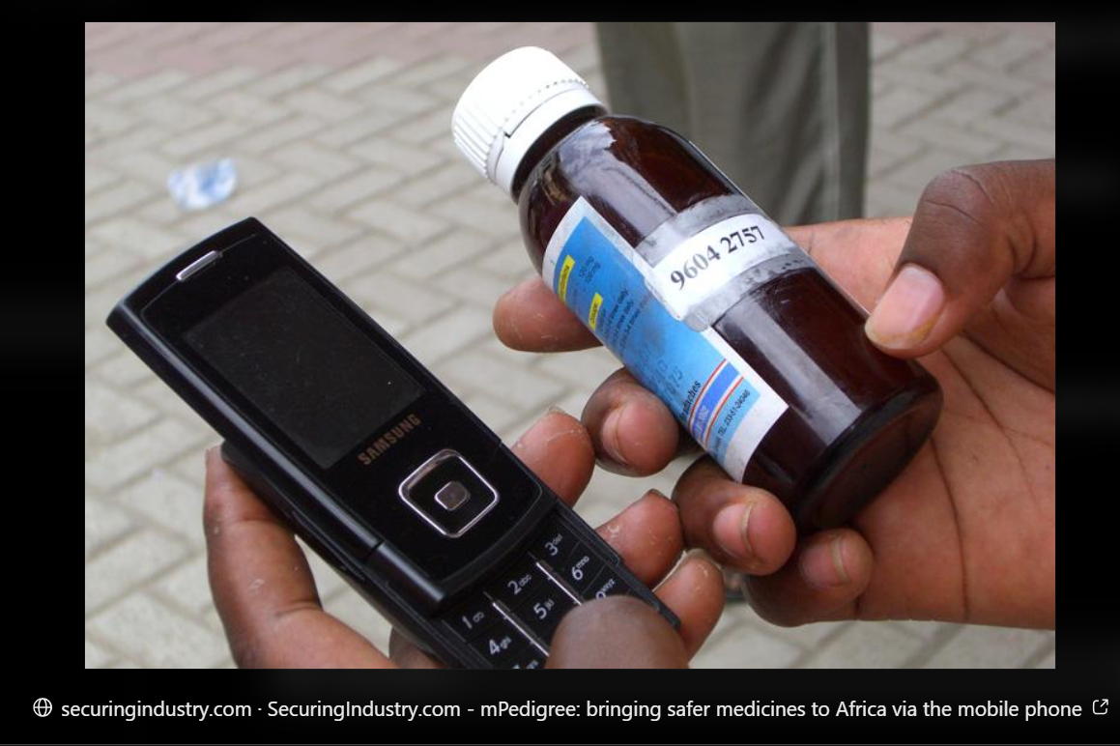
Figure 2.1 mPedigree Goldkeys Product Verification

2.3.2 Sproxil Mobile Authentication Service
Sproxil is a for-profit company founded in 2009 by Ashifi Gogo, with roots in mPedigree (World Economic Forum, 2017). Its mobile verification service places a scratch-off label with a unique code on each protected product; the consumer sends the code by text message to a number that works across all mobile networks in the country and receives an instant reply stating whether the product is real or fake, while every code is tracked on a central server. Free access was found to be necessary to encourage participation. The service operates in Nigeria, Ghana, Kenya, Mali, Tanzania, India and Pakistan, and had handled over 35 million verification requests by 2016 (World Economic Forum, 2017).
Strengths and limitations. Sproxil showed that free SMS verification can be adopted at national scale, and that aggregated verification data helps regulators identify counterfeit hotspots (World Economic Forum, 2017). Its coverage, however, depends on manufacturers paying for the service, and pharmaceutical firms often resist paying unless pressured; as a commercial, brand-funded service it serves enrolled brands rather than the many everyday product categories made by small Kenyan manufacturers (World Economic Forum, 2017). Figure 2.2 shows the service.
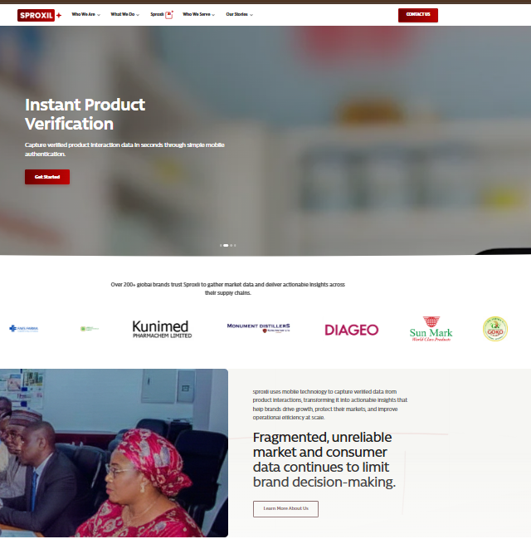
Figure 2.2 Sproxil Mobile Authentication Service

2.3.3 KRA Excisable Goods Management System and Soma Label App
Under the Excise Duty (Excisable Goods Management System) Regulations, 2017, excisable products manufactured in or imported into Kenya must carry excise stamps (Kenya Revenue Authority, 2021). The stamps, managed through the Excisable Goods Management System (EGMS), carry a Quick Response (QR) code that enables distributors, retailers and consumers to authenticate products and to trace excisable goods through the distribution chain (Capital FM, 2016). In 2021 KRA introduced a new generation of stamps with enhanced security features for alcoholic beverages, tobacco products, water, soft drinks and juices, and members of the public can verify them using the Soma Label mobile application available on the Google Play Store and Apple App Store (Kenya Revenue Authority, 2021; Business Daily, 2021).
Strengths and limitations. The EGMS is backed by law and covers every unit of the products it applies to, and the Soma Label app gives consumers a direct check of the stamp. However, verification requires a smartphone with a camera and a data connection, and the system covers only excisable goods, so medicines, cosmetics, electronics and most foods are outside its scope (Kenya Revenue Authority, n.d.; Kenya Revenue Authority, 2021). Figure 2.3 shows the application.
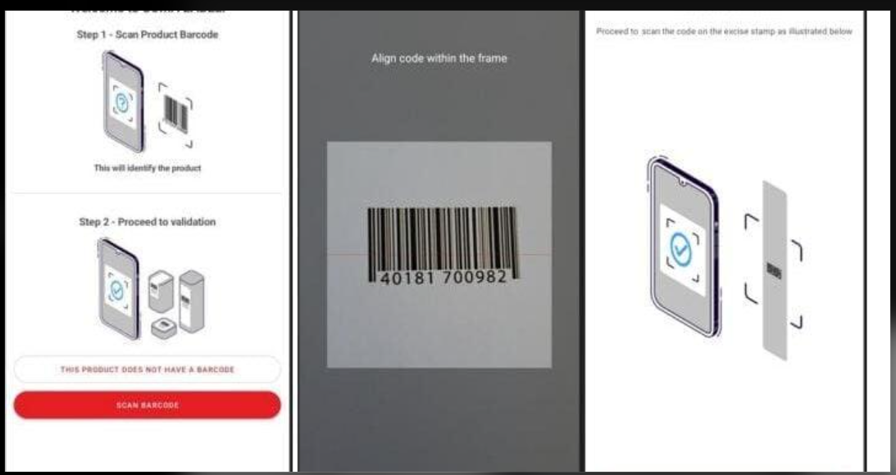
Figure 2.3 KRA Excise Stamp Verification (Soma Label App)

2.3.4 KEBS Standardization Mark SMS Verification
The Kenya Bureau of Standards (KEBS) issues Standardization Mark (S-Mark) permits to products that meet Kenyan standards. Members of the public can confirm that the S-Mark permit on a product is valid by sending "SM#PERMIT NUMBER" by SMS to 20023, by using the KEBS mobile application on the Google Play Store or Apple App Store, through the KEBS website, or by calling the toll-free number 1545 (Kenya Bureau of Standards, 2024). The SMS reply confirms the validity and details of the manufacturing permit, and consumers are encouraged to report to KEBS if the details differ from the product (Capital FM, 2020).
Strengths and limitations. The KEBS service is the closest Kenyan precedent for SMS verification: it works on any phone and covers many product categories. However, it verifies the permit of a product line rather than an individual unit, so the same permit number appears on every genuine and counterfeit item that copies it, and the service does not record how often or where a number is checked (Kenya Bureau of Standards, 2024; Lehtonen et al., 2009). Figure 2.4 shows the service.

Figure 2.4 KEBS Standardization Mark Verification by SMS

2.3.5 Comparison of Reviewed Systems
Table 2.1 compares the reviewed systems against the challenges identified in Section 2.2. Only features documented in the cited sources are recorded; "Not documented" means that the feature is not described there, not that it is known to be absent.
Feature (as documented) | mPedigree (Goldkeys) | Sproxil | KRA EGMS / Soma Label | KEBS S-Mark SMS
Works on a basic phone (SMS) | Yes (shortcode 1393) | Yes | No (smartphone app) | Yes (20023)
Unique code per unit | Yes (scratch PIN) | Yes (scratch code) | Yes (stamp) | No (permit per product line)
Product categories | Medicines, agro-inputs, textiles | Enrolled brands | Excisable goods only | Products with an S-Mark
Detection of copied codes | Not documented | Codes tracked centrally | Not documented | No
Consumer reporting channel | Not documented | 24/7 call centre | Not documented | Toll-free line 1545
Data for brand owners or regulators | Supply chain tools | Hotspot data | Stamp tracking | Not documented
Who pays | Brand owner | Brand owner | Government | Government
Table 2.1 Comparison of Existing Product Verification Systems

2.3.6 Usability, Accessibility and Functional Limitations
Although these systems show clear progress, each has limitations when applied to the wider Kenyan market. Smartphone and QR-based tools such as the Soma Label app exclude consumers with basic phones or without data bundles, who remain a substantial share of mobile users (Communications Authority of Kenya, 2025). Physical security features can be imitated and cannot tell the buyer whether a specific item is genuine (Staake et al., 2009). Systems focused on a single sector, such as medicines or excisable goods, or funded by enrolled brand owners, do not serve the many other product categories that are commonly counterfeited (Anti-Counterfeit Authority, n.d.-b; World Economic Forum, 2017).
A further limitation is that many verification tools answer the consumer’s question but do not turn verification activity into useful intelligence. If a code is only checked for existence, a counterfeiter who copies a single genuine code onto thousands of fake packs will receive a “genuine” reply every time. Without recording how often and where each code is checked, the system cannot detect cloned codes (Lehtonen et al., 2009).

2.3.7 Identified Gaps from Reviewed Systems
From the review, the following gaps were identified:
- Verification channels that depend on smartphones and internet access exclude a large share of consumers.
- Many systems confirm that a code exists but do not detect a genuine code that has been copied and reused on counterfeit products.
- Consumers lack a simple way to report suspected counterfeits together with the product code and location.
- Manufacturers and regulators rarely receive real-time, aggregated data on where and how often products are checked.
- Sector-specific solutions leave many everyday product categories without any verification tool.
Together, these gaps show that existing services rarely combine verification on any phone, detection of cloned codes through repeated-check analysis, consumer reporting with the product code attached, and aggregated data for manufacturers and regulators across product categories (Mackey & Nayyar, 2017; Rasheed et al., 2018).

2.4 Concepts and Technologies Underpinning Code-Based Product Verification
Beyond individual systems, the literature describes the concepts and technologies on which code-based product verification is built. This section reviews them independently of any particular system.

2.4.1 Mass Serialisation and Unique Product Codes
Mass serialisation assigns a unique identifier to every saleable unit so that each item can be checked individually against the manufacturer's records, rather than relying on features that are identical on every pack (Mackey & Nayyar, 2017). For a code to resist guessing it must be drawn at random from a space much larger than the number of codes issued, and it should be hidden, for example under a scratch-off panel, until purchase (Rasheed et al., 2018; World Economic Forum, 2017).

2.4.2 SMS as a Verification Channel
Short Message Service (SMS) works on every mobile phone, including basic feature phones, and needs no data bundle or application, which makes it suitable where smartphone ownership and internet access are uneven (Communications Authority of Kenya, 2025; Rasheed et al., 2018). SMS gateways receive messages sent to a shortcode and forward them to an application through a callback, and send the application's replies back to the phone (Africa's Talking, n.d.).

2.4.3 Detection of Cloned Codes
A unique code proves authenticity only once: a counterfeiter who copies one genuine code onto many fake packs will receive a "genuine" reply each time the code is merely looked up. Research on RFID tag cloning shows that cloned identifiers can be detected by analysing the history of where and how often each identifier is read, and flagging identifiers whose read pattern is implausible for a single genuine item (Lehtonen et al., 2009). The same principle applies to printed codes checked by consumers.

2.4.4 Cloud Databases, Access Control and Data Protection
Managed cloud database services provide storage, authentication and server-side functions without the cost of running servers, and row-level security allows access rules to be enforced by the database itself so that each organisation sees only its own records (Supabase, n.d.). Because verification records include phone numbers and locations, their collection and processing must comply with the Data Protection Act, 2019 (Republic of Kenya, 2019).

2.4.5 Evaluation of Verification Systems
Pressman and Maxim (2015) describe a layered testing approach that proceeds from unit tests of individual components, through integration testing, to validation against user requirements. For verification services, evaluation must also show that invalid, deactivated and repeatedly checked codes produce the correct warnings, and usability evaluation should confirm that users understand the message format and the replies (Sommerville, 2016).

2.5 Summary
This chapter reviewed the challenges of detecting counterfeit products through appearance, physical security features and manual inspection, and the regulatory and communication barriers that allow fakes to circulate. It then reviewed four existing systems related to product verification: mPedigree, Sproxil, the KRA excise stamp system with the Soma Label app, and the KEBS Standardization Mark SMS check. The comparison showed gaps in access for basic phone users, verification of individual units across product categories, detection of cloned codes, consumer reporting and data for manufacturers and regulators. Finally, the chapter reviewed mass serialisation, SMS as a verification channel, cloned-code detection, cloud databases with access control and data protection, and approaches to evaluating verification systems.

CHAPTER THREE: SYSTEM DEVELOPMENT METHODOLOGY

3.1 Introduction
This chapter describes the methodology used to develop the SMS-based counterfeit product tracking system. It explains why an iterative approach was chosen and describes the phases through which the system was built, tested and deployed. The Agile methodology was chosen because it allows a system to be built and improved in small, working stages.

3.2 Methodological Approach
The project followed the Agile software development methodology. Agile delivers software in short iterations, each of which produces a working increment that can be demonstrated, reviewed and improved. This approach suited the project because the requirements evolved during development: the system began as a front-end prototype with sample data, was then connected to a live database, and later gained features such as manufacturer self-registration and administrator-created accounts in response to review feedback. The external SMS gateway also introduced uncertainty, which Agile handles well because work can be re-planned between iterations (Beck et al., 2001; Sommerville, 2016). This meant that a working version of the system was always available for review.
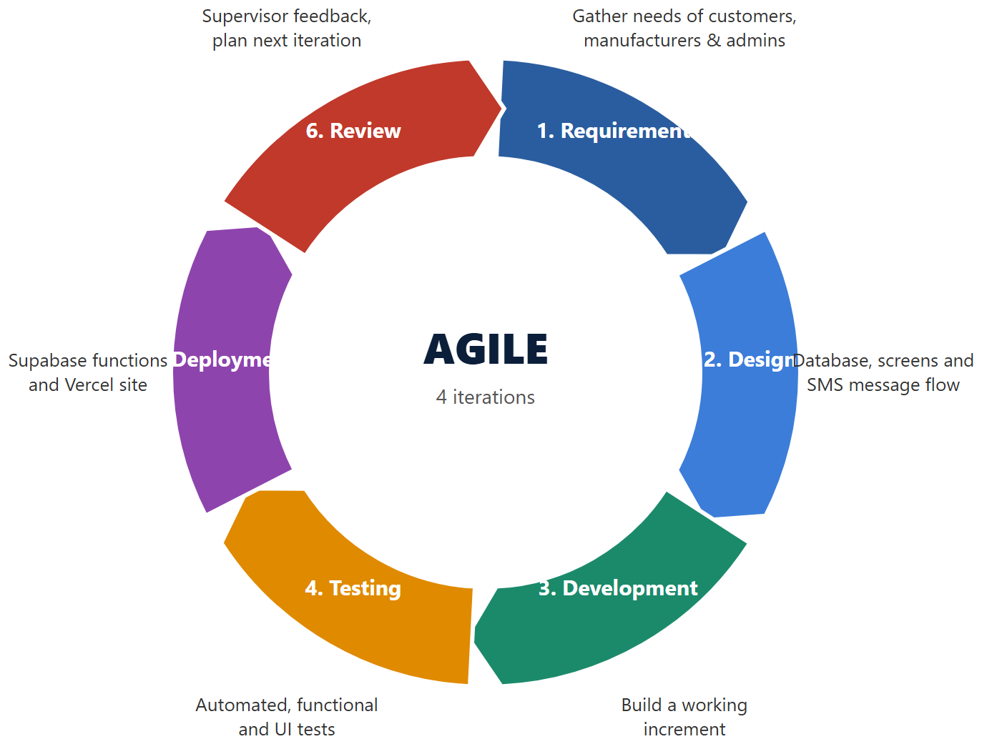
Figure 3.1 Agile Development Cycle

3.3 Agile Development Phases
Development was organised into the iterations summarised in Table 3.1. Each iteration ended with a working version of the system.
Iteration | Main work completed
1. Front-end prototype | Manufacturer App and Admin Dashboard screens built with sample (mock) data; service layer designed so that the data source could later be replaced.
2. Database and back end | Supabase database schema, row-level security rules, code generation and SMS verification logic written as database functions; demonstration data loaded.
3. SMS gateway integration | Edge Function to receive Africa’s Talking messages and send replies; public SMS simulator connected to the live verification logic.
4. Accounts and deployment | Administrator-created manufacturer logins, manufacturer self-registration with approval, security hardening, and deployment to Vercel.
Table 3.1 Development Iterations

3.3.1 Requirements Phase
Requirements were identified through interviews, questionnaires and observation in Kajiado Town, a review of literature and through analysis of existing verification systems. The requirements were grouped into three modules: the Manufacturer module (products, batches, codes and monitoring), the Administrator module (oversight, investigation and configuration) and the Customer SMS module (verification and reporting). These requirements were refined in later iterations as feedback was received.

3.3.2 Design Phase
In the design phase, user interface layouts, the database structure and the flow of an SMS message through the system were planned. Particular attention was given to security: deciding which data each role may read or change, keeping secret keys out of the browser, and hiding the administrator entry point from the public login page. The resulting diagrams are presented in Chapter Five.

3.3.3 Development Phase
Development proceeded iteratively. Each iteration ended with a working version that could be run, reviewed and demonstrated. For example, the interface was first completed with sample data so that its design could be reviewed before any database work began, and the data layer was then replaced without changing the pages. Features such as manufacturer self-registration were added in later iterations in response to feedback.

3.3.4 Testing Phase
Testing was carried out during every iteration. It included automated tests of the database functions and security rules, tests of the server functions using requests in the SMS gateway’s format, type checking and production builds of the front end, and visual checks of the interface at desktop and mobile screen sizes. Details are given in Chapter Seven. Problems found were fixed before the next iteration began.

3.3.5 Deployment Phase
The database and server functions were deployed to Supabase and the web application to Vercel, producing a public address that works on any device without running software locally. Deployment was repeated after each change so that the live version always reflected the latest tested code. This allowed the supervisor and test users to open the latest version from any browser.

3.3.6 Review Phase
After each iteration the system was reviewed against the objectives and feedback from the project supervisor, Mr. Alianda. Reviews led to changes such as removing demonstration accounts from the login page, allowing customers to enter their own phone number in the simulator, making dashboard statistics clickable, and adding manufacturer self-registration. This kept the system aligned with the project objectives.

3.4 Summary
The Agile methodology allowed the system to be built in working increments, from an interface prototype to a deployed system with a live database, SMS integration and account management. Continuous testing and review at each iteration helped the project respond to changing requirements and to an external dependency on the SMS provider. As a result, a tested, working system was available at every stage of the project.

CHAPTER FOUR: REQUIREMENTS GATHERING AND ANALYSIS

4.1 Introduction
This chapter describes how the requirements of the SMS-based counterfeit product tracking system were gathered and analysed. The aim was to understand the needs of consumers, manufacturers and regulators, and to use these needs to guide the design of the system.
The requirements gathering process focused on how consumers currently check products, how manufacturers learn about counterfeits, and what retailers and regulatory officers need for monitoring and enforcement. Existing studies and reports were also reviewed to understand the wider problem of counterfeiting in Kenya. The insights obtained during this phase informed the system’s SMS verification rules, database structure, role-based dashboards and counterfeit reporting workflow.

4.2 Data Collection Approach
A mixed-method (qualitative and quantitative) approach was adopted, combining the two kinds of data so that the strengths of each compensate for the limitations of the other (Creswell & Plano Clark, 2018). Interviews and observation helped the study understand people's experiences with counterfeit products and how goods are checked in practice, while questionnaires allowed simple counts of how common those experiences and views are across the stakeholder groups.
Data was collected through interviews, questionnaires and observation in Kajiado Town and the surrounding retail areas, supported by a review of literature and existing systems. These methods allowed stakeholders to describe how they check products today, their experiences with counterfeit goods, and what they would expect from a verification and tracking service.
The mixed-method approach ensured that the system requirements were based both on real experiences and on measurable patterns, enabling the design of a verification service that works for consumers with any type of phone while giving manufacturers and administrators useful data.

4.3 Data Collection Methods
To ensure accurate and comprehensive system requirements, both primary and secondary data collection methods were used. Combining these approaches enabled cross-checking of information and improved the reliability of the findings.
Primary data was collected directly from consumers, manufacturers or brand representatives, retailers or shop owners and regulatory officers through interviews, questionnaires and observation. Secondary data came from published reports, academic studies, laws and the documentation of existing verification systems. Primary data are collected for the purpose of the study at hand, while secondary data were originally collected for other purposes (Saunders, Lewis & Thornhill, 2019).
The main techniques used were:
- Interviews with five consumers, two manufacturer or brand representatives, three retailers or shop owners and two regulatory officers.
- Questionnaires administered to 50 respondents: 30 consumers, 5 manufacturer or brand representatives, 10 retailers or shop owners and 5 regulatory officers.
- Observation of how products are sold and checked in shops and retail areas in Kajiado Town.
- Review of relevant literature, reports and existing product authentication systems.

4.4 Primary Data Collection
Primary data collection focused on obtaining direct insights from the stakeholders involved in buying, selling, producing and regulating products. A total of 50 people completed questionnaires and 12 were interviewed, comprising:
Stakeholder group | Questionnaire respondents | Interviews
Consumers / customers | 30 | 5
Manufacturers / brand owners | 5 | 2
Retailers / shop owners | 10 | 3
Regulatory officers | 5 | 2
Total | 50 | 12
Table 4.1 Primary Data Collection
Data was collected in Kajiado Town and the surrounding retail areas of Kajiado County, Kenya, during July 2026. Respondents were selected by convenience sampling, in which people who are easily accessible and willing to take part are included (Etikan, Musa & Alkassim, 2016). Before taking part, each participant was told the purpose of the study and gave verbal consent, and no unnecessary personal identifying information was recorded, in line with the Data Protection Act, 2019 (Republic of Kenya, 2019).

4.5 Data Analysis
Quantitative responses were summarised using counts and percentages, while interview responses were analysed thematically, by identifying and grouping recurring patterns in the data (Braun & Clarke, 2006). Twelve questionnaire items were analysed: four for consumers, four for manufacturers or brand representatives and four for retailers and regulatory officers.

4.5.1 Interview Data Summary
Tables 4.2 to 4.4 summarise the themes explored in the interviews with each stakeholder group.
Consumer Interview Summary
Theme | Key insights from consumers
Experience with counterfeits | Some participants had bought products they later suspected were fake.
How products are currently checked | Mainly by packaging, price, expiry dates and the reputation of the seller.
Phone type and SMS use | Participants were interested in a service that works by SMS without needing internet access.
Reporting suspected fakes | Not discussed in detail in the interviews; the questionnaire shows that only 4 of the 19 consumers who suspected a fake reported it (Figure 4.3).
Expectations of a verification service | A simple SMS service that confirms whether a product is genuine, without requiring internet access.
Table 4.2 Consumer Interview Summary
Manufacturer Interview Summary
Theme | Key insights from manufacturers
Impact of counterfeiting on the business | Counterfeits reduce customer trust and affect sales.
Current anti-counterfeiting measures | They rely on customer complaints, distributors, market information and the authorities to learn about suspected counterfeits.
Visibility of products after distribution | Information about products after distribution arrives indirectly, through complaints, distributors and market reports.
Willingness to print unique codes | Willing to use unique verification codes if the system is affordable and easy to implement.
Expectations of a tracking dashboard | A dashboard showing verification activity and suspicious products would be useful.
Table 4.3 Manufacturer Interview Summary
Retailer and Regulatory Officer Interview Summary
Theme | Key insights from retailers / regulatory officers
Common counterfeit product categories | Cooking oil and soap.
How counterfeits are detected today | Through customer complaints, inspection, differences in packaging and information from the market.
Handling of consumer complaints | Customer complaints are one of the main ways suspected counterfeits come to light.
Information needed for enforcement | Product name, product code, manufacturer, verification status, date, time and location.
Expectations of the system | A centralised record that keeps verifications and counterfeit reports in one place.
Table 4.4 Retailer and Regulator Interview Summary

4.5.2 Questionnaire Analysis
Consumer Questionnaire Analysis
A total of 30 consumers participated in the survey. The objective of this questionnaire was to understand how consumers check whether products are genuine, the type of phones they use, their experience of buying and reporting counterfeit goods, and whether they would verify products by SMS.
Question 1: How do you currently check whether a product is genuine?
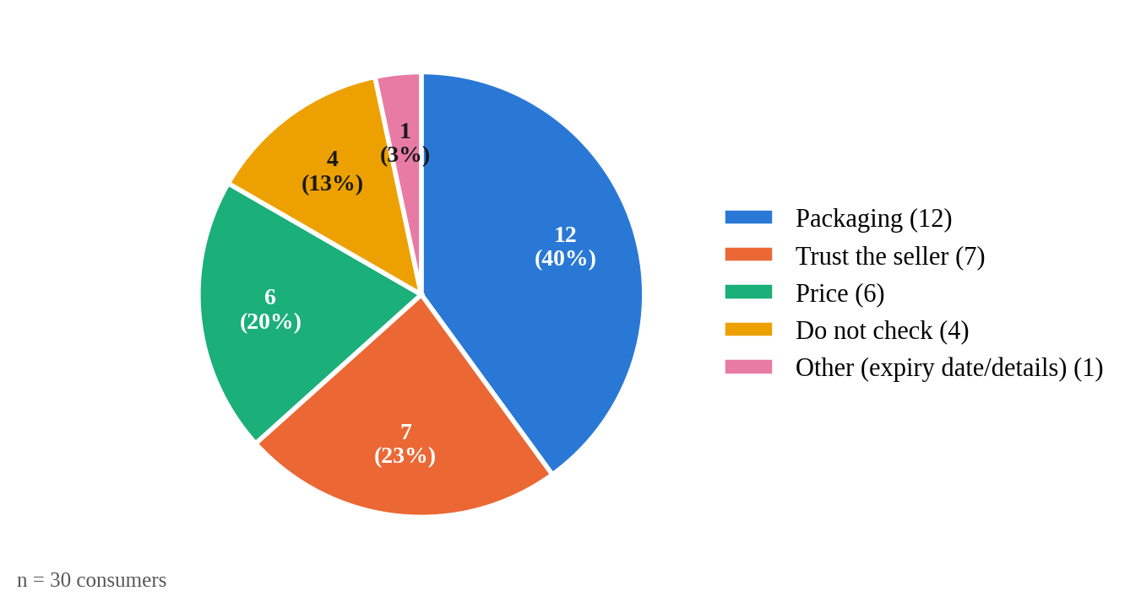
Figure 4.1 Methods Consumers Use to Check Products
Analysis
Of the 30 consumers, 12 (40%) judge a product mainly by its packaging, 7 (23%) trust the seller, 6 (20%) rely on price and 4 (13%) do not check at all; one respondent checks the expiry date and product details. Almost every method in use depends on appearance or trust, which counterfeiters can imitate, so consumers have no reliable way to confirm that a product is genuine at the point of purchase.
System Solution
The system lets a consumer send the product’s unique code by SMS and receive an immediate reply stating whether the product is genuine, suspicious, invalid or deactivated.
Question 2: What type of mobile phone do you use?
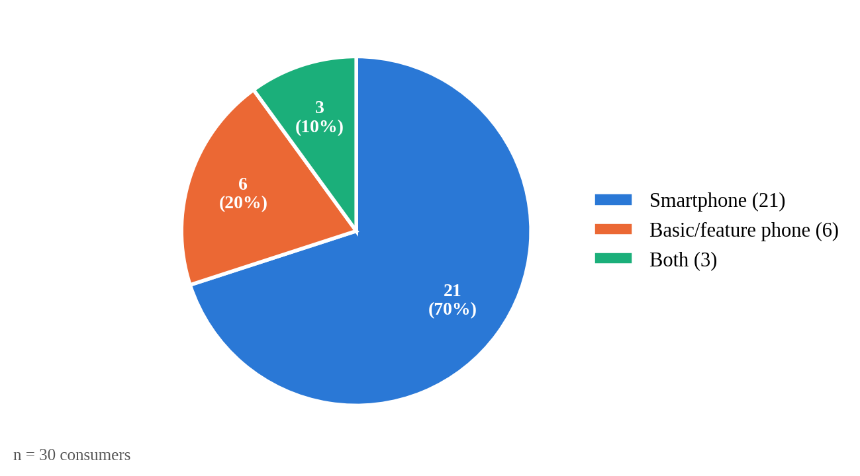
Figure 4.2 Types of Mobile Phones Used by Respondents
Analysis
21 of the 30 consumers (70%) use a smartphone, 6 (20%) use only a basic or feature phone and 3 (10%) use both. Although most respondents own smartphones, one in five would be excluded by an app-based or QR-code tool. In addition, 23 consumers (77%) said they would verify a product by free SMS, 5 (17%) said maybe and only 2 (7%) said no, which shows strong acceptance of an SMS channel that works on every phone.
System Solution
Verification uses plain SMS, so it works on basic phones as well as smartphones and needs no internet connection or app installation.
Question 3: Have you ever bought a product you later suspected was counterfeit? If so, did you report it?
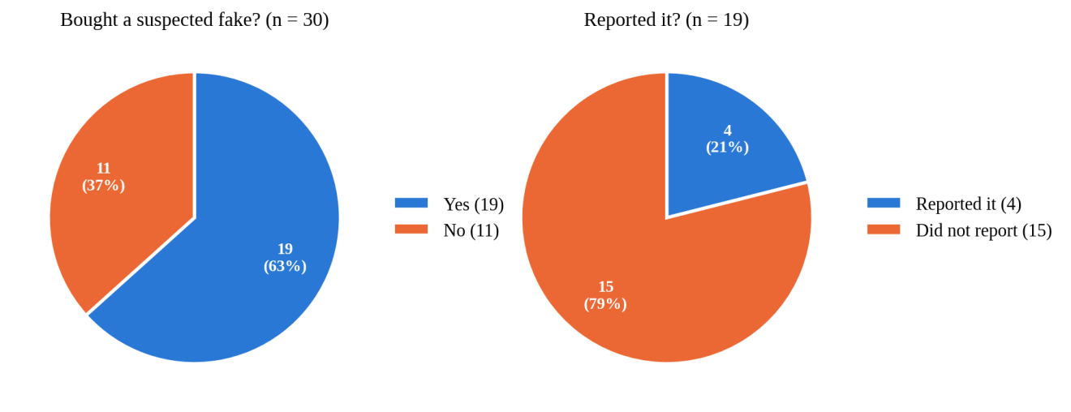
Figure 4.3 Experience and Reporting of Counterfeit Products
Analysis
19 of the 30 consumers (63%) had bought a product they later suspected was counterfeit. Of these 19, only 4 (21%) reported it, while 15 (79%) did not. Counterfeits are therefore a common experience, but most cases never reach manufacturers or the authorities, which confirms the need for a simple reporting channel.
System Solution
Customers can report a suspected fake by sending “REPORT <code> <reason>”. The report receives a reference number and appears in the administrator’s Counterfeit Reports workflow.
Question 4: Would you send a free SMS to verify a product before buying it?
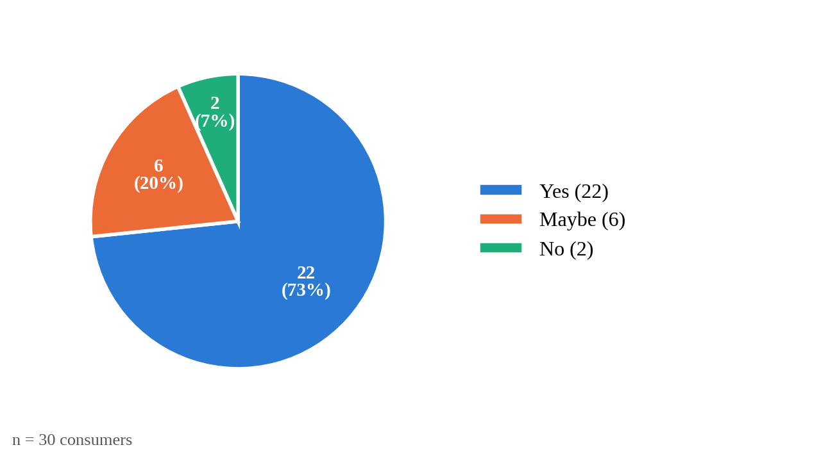
Figure 4.4 Willingness to Verify Products by SMS
Analysis
22 of the 30 consumers (73%) said they would send a free SMS to verify a product before buying it, 6 (20%) said maybe and only 2 (7%) said no. Together with the finding that one in five consumers uses only a basic phone, this shows strong demand for a verification channel that is free and works on any phone.
System Solution
Verification is free to the customer and uses a short, fixed format ("VERIFY <code>"). Messages in any other format receive a help reply that explains the correct format.
Manufacturer Questionnaire Analysis
A total of 5 manufacturers or brand representatives participated in the survey. The questionnaire focused on how they learn about counterfeits of their products, their willingness to adopt unique product codes, the information they need and the effect of counterfeits on their business.
Question 1: How do you currently learn about counterfeits of your products?
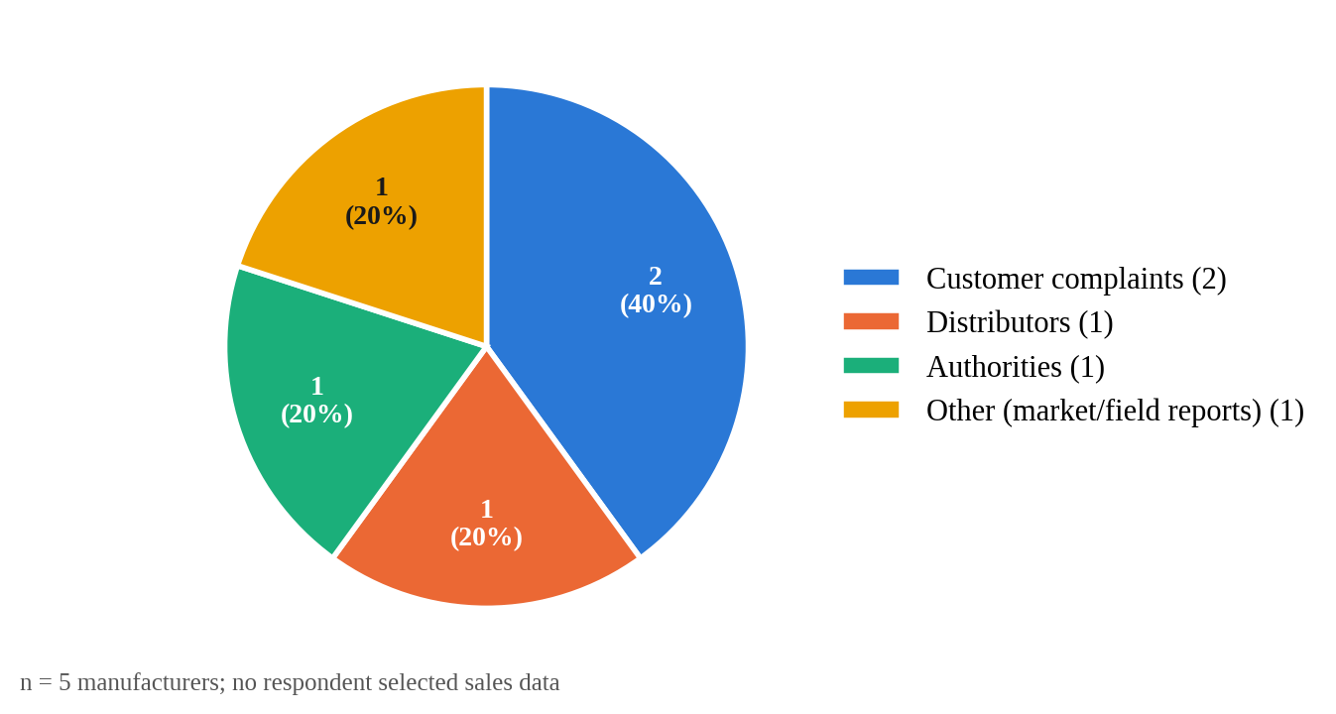
Figure 4.5 How Manufacturers Learn About Counterfeits
Analysis
Of the 5 manufacturers, 2 (40%) learn about counterfeits mainly through customer complaints, and one each through distributors, the authorities and market or field reports. None rely on sales data. Manufacturers therefore learn about counterfeits indirectly and often late, after customers have already been affected.
System Solution
The Manufacturer App shows every verification of the company’s products, highlights codes checked more times than allowed, and lists consumer reports about its products.
Question 2: Would you be willing to print a unique code on each unit of your product?
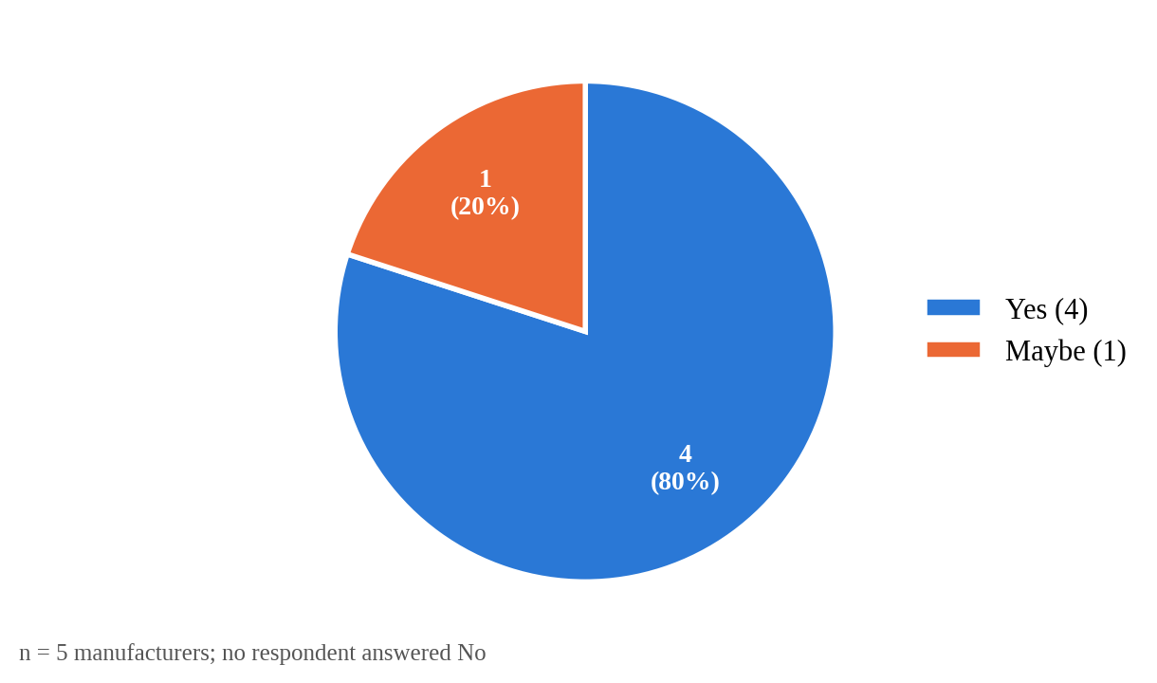
Figure 4.6 Willingness to Adopt Unique Product Codes
Analysis
4 of the 5 manufacturers (80%) would print a unique code on each unit and 1 (20%) might; none refused. In the interviews, manufacturers said adoption depends on the system being affordable and easy to implement.
System Solution
When a batch is created, the system generates one random nine-digit code per unit, which the manufacturer can export as a CSV file for printing.
Question 3: Which information would help you most?
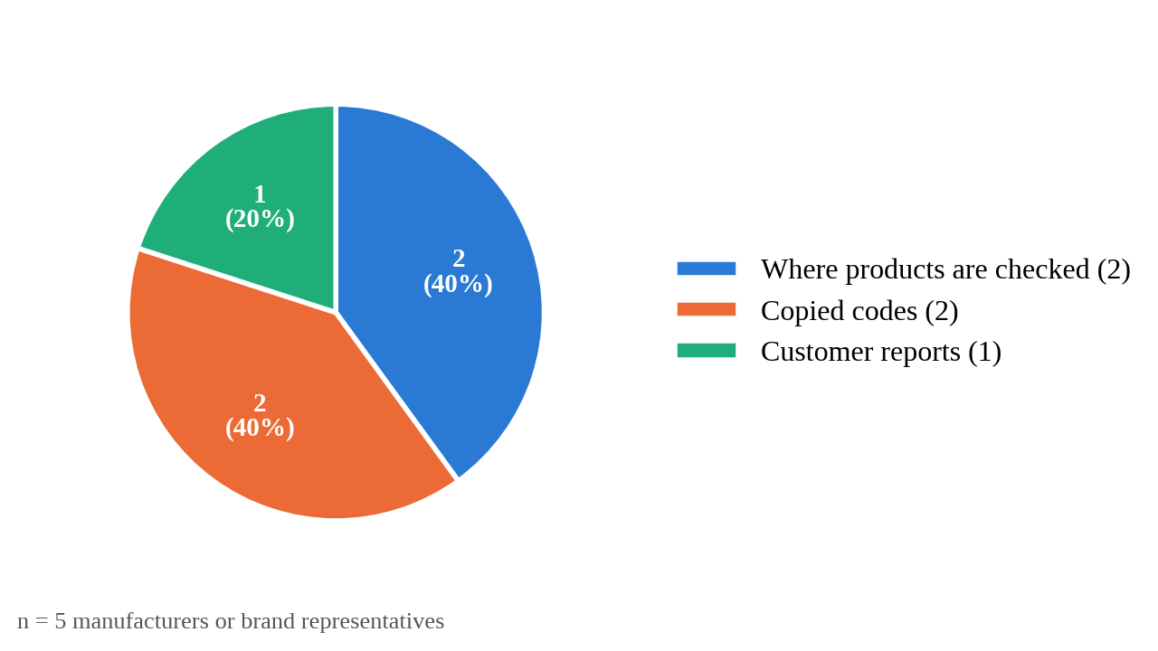
Figure 4.7 Information Most Useful to Manufacturers
Analysis
Two of the 5 manufacturers (40%) said that knowing where their products are checked would help them most, 2 (40%) wanted to know about copied codes and 1 (20%) wanted customer reports. All three kinds of information depend on recording each verification rather than simply answering it.
System Solution
The Manufacturer App shows every verification of the company's products with its location, highlights codes checked more times than the threshold as possibly copied, and lists customer reports about the company's products.
Question 4: Have counterfeits of your products affected your sales or brand reputation?
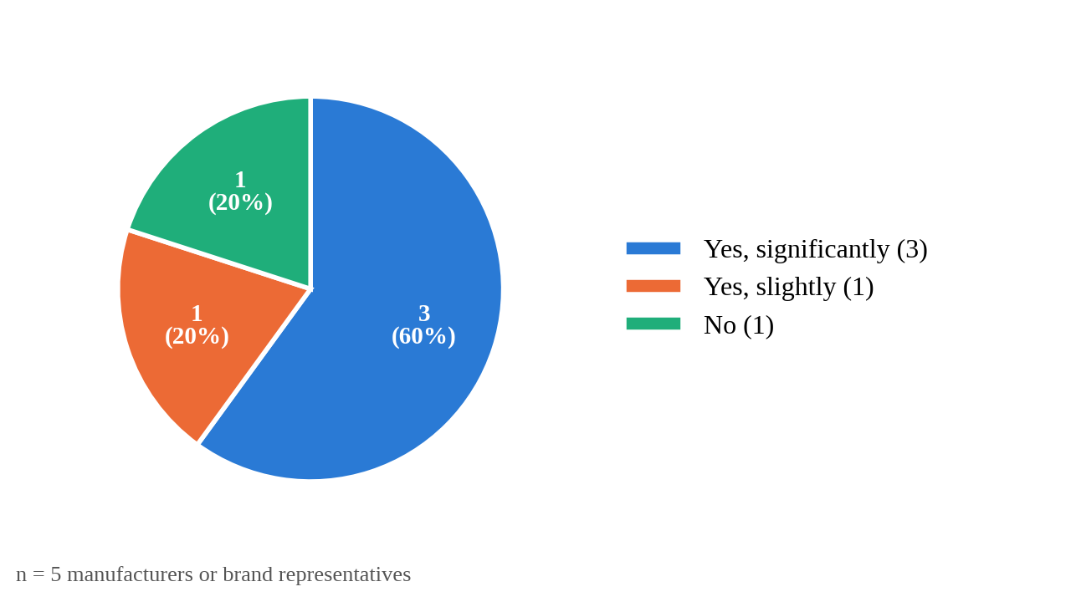
Figure 4.8 Effect of Counterfeits on Manufacturers
Analysis
Three of the 5 manufacturers (60%) said counterfeits had significantly affected their sales or brand reputation, 1 (20%) said slightly and 1 (20%) said not at all. Four of five manufacturers have therefore been harmed by counterfeits, which explains their willingness to adopt unique codes (Figure 4.6).
System Solution
Unique codes, cloned-code detection and consumer reports give manufacturers early evidence of counterfeiting and of where it occurs, which they can use to warn customers and to support enforcement action.
Retailer and Regulatory Officer Questionnaire Analysis
A total of 15 respondents, 10 retailers or shop owners and 5 regulatory officers, participated in the survey. The purpose of this questionnaire was to establish which products are most often counterfeited, whether a central record of verifications and reports would help in tracking counterfeit products, how often counterfeits are encountered and which verification channel would be most practical for consumers.
Question 1: Which product categories are most often counterfeited in your experience?
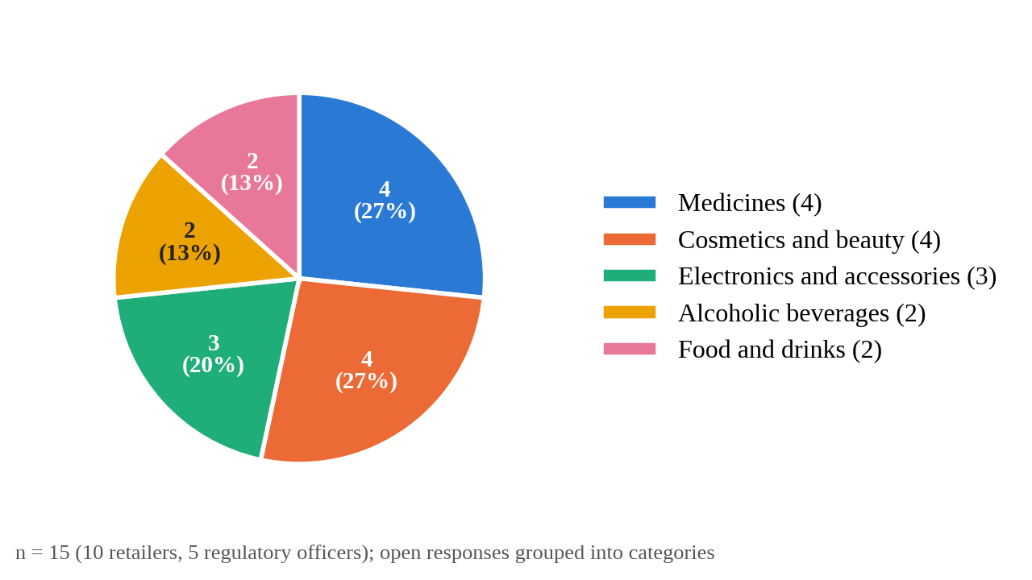
Figure 4.9 Product Categories Most Often Counterfeited
Analysis
The open responses were grouped into categories. Medicines and cosmetics were each named by 4 of the 15 respondents (27%), electronics and phone accessories by 3 (20%), and alcoholic beverages and food and drinks by 2 each (13%). Counterfeiting is therefore spread across many categories, consistent with the Anti-Counterfeit Authority's observation that fakes affect a wide range of everyday goods (Anti-Counterfeit Authority, n.d.-b).
System Solution
The system is not limited to one sector: any approved manufacturer can register products of any category and generate codes for them.
Question 2: Would a central record of verifications and reports help in tracking counterfeits?
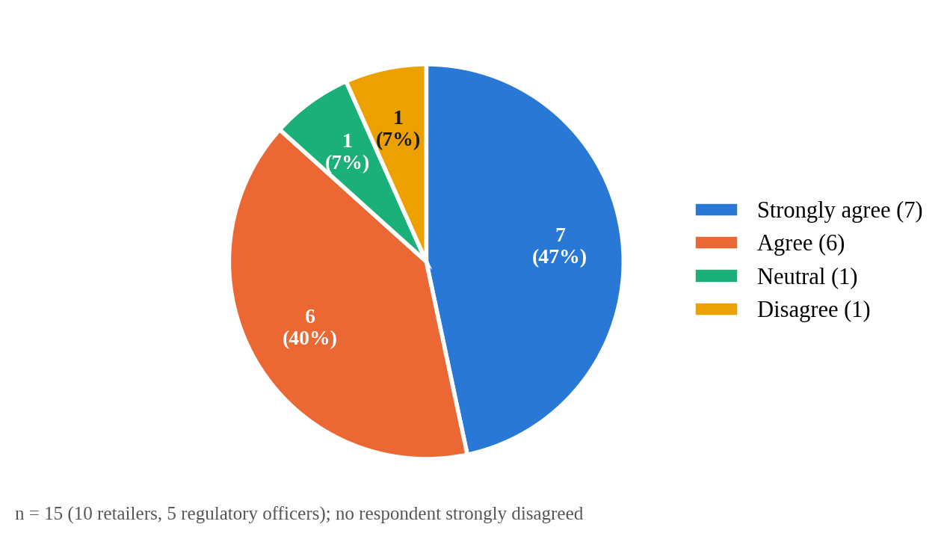
Figure 4.10 Perceived Value of Central Verification Data
Analysis
Of the 15 retailers and regulatory officers, 13 (87%) agreed or strongly agreed (7 strongly agree, 6 agree) that a central record of verifications and reports would help in tracking counterfeits; 1 was neutral and 1 disagreed. This shows strong support for a centralised monitoring system.
System Solution
The Admin Dashboard brings together verification logs, suspicious codes, counterfeit reports and a hotspot view of locations with many suspicious or invalid checks.
Question 3: How often do you encounter suspected counterfeit products?
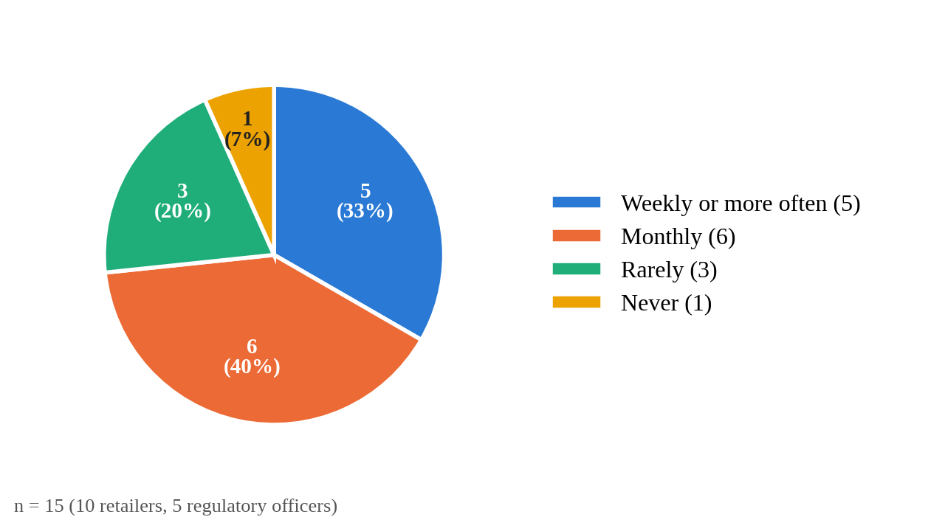
Figure 4.11 Frequency of Encountering Suspected Counterfeits
Analysis
Five of the 15 respondents (33%) encounter suspected counterfeit products weekly or more often and 6 (40%) monthly, so nearly three quarters (73%) meet them at least once a month; 3 (20%) rarely do and only 1 (7%) never does.
System Solution
Every verification and report is recorded with its location, and the Admin Dashboard shows suspicious codes and a hotspot view of locations with many suspicious checks, so that frequent problems can be targeted.
Question 4: Which verification channel would be most practical for consumers?
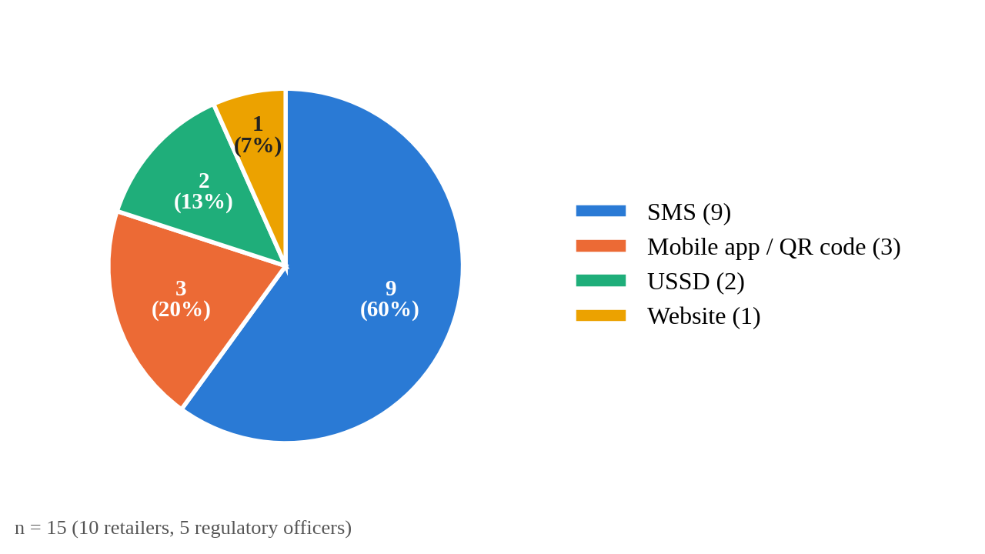
Figure 4.12 Most Practical Verification Channel for Consumers
Analysis
Nine of the 15 respondents (60%) chose SMS as the most practical channel for consumers, 3 (20%) a mobile app or QR code, 2 (13%) USSD and 1 (7%) a website. This matches the continued use of basic phones reported by consumers and in national statistics (Communications Authority of Kenya, 2025).
System Solution
SMS is the primary verification channel, so no app, camera or internet connection is needed. USSD is identified as future work.

4.6 Secondary Data Collection
Secondary data was obtained from the Anti-Counterfeit Act, 2008; publications of the Anti-Counterfeit Authority and the Office of the Auditor-General; sector statistics from the Communications Authority of Kenya; Kenya Revenue Authority information on excise stamps; published studies of counterfeiting, product authentication and cloned-code detection (Lehtonen et al., 2009; Mackey & Nayyar, 2017; Rasheed et al., 2018; Staake et al., 2009); and the technical documentation of React, Supabase, Vercel and Africa’s Talking.
This review helped identify the scale of counterfeiting in Kenya, the institutions responsible for enforcement, the strengths and weaknesses of existing authentication systems, and the technical options for building an SMS-based service. The sources showed that counterfeiting affects many everyday product categories, that enforcement is constrained by limited inspection capacity, and that existing verification tools either depend on smartphones or serve a single sector. These findings closely aligned with the issues identified during primary data collection.
The secondary data therefore confirmed the need for a verification channel accessible on any phone, with built-in detection of cloned codes and central reporting for manufacturers and regulators.

4.7 Stakeholders Identification
Stakeholders are the people and organisations who are affected by a system or can influence its requirements (Sommerville, 2016). The effectiveness of the SMS-based counterfeit product tracking system depends on the coordinated involvement of several stakeholder groups, each contributing to the system's functionality and overall value.
Customers (consumers) are the primary users of the verification service. They verify products and report suspected counterfeits by SMS, which requires the service to be simple, fast and usable on any mobile phone.
Manufacturers register their products and batches, obtain and print verification codes, and monitor verification activity and reports about their own products.
The system administrator approves manufacturers, monitors all activity, investigates suspicious codes and manages counterfeit reports and system settings. In practice, this role could be held by a regulator or an industry body.
Retailers benefit from being able to show customers that their stock is genuine.
The SMS gateway provider delivers messages between customers and the system.
Regulatory authorities could use verification and report data to target inspections and awareness campaigns.

4.8 Challenges in Requirements Gathering and Analysis
During requirements gathering and analysis, several challenges were encountered that required adaptive strategies to ensure that realistic requirements were established.
- Participant Hesitancy:
Some participants were initially hesitant to give information because they were concerned about how their responses would be used. This was addressed by explaining the purpose of the research and assuring them that the information would be used only for academic purposes.
- Limited Stakeholder Availability:
Some manufacturers and regulatory personnel were difficult to reach because of their availability. This was handled by approaching the representatives who were available and arranging interviews at convenient times.
- Limited Time and Transport Resources:
Limited time and transport resources restricted how widely data could be collected, so data collection was carried out in Kajiado Town and the surrounding retail areas.
Despite these challenges, the combination of primary and secondary data and flexible analysis methods ensured that the needs of each stakeholder group were clearly identified.

4.9 Summary
This chapter described how requirements were gathered from stakeholders and secondary sources and analysed through twelve questionnaire items. The analysis showed that most consumers rely on appearance or trust, that one in five uses only a basic phone, that most have bought suspected counterfeits but few reported them, and that 73% would verify products by a free SMS. Manufacturers have been harmed by counterfeits, are willing to print unique codes and most want to know where products are checked and which codes are copied. Retailers and regulatory officers encounter counterfeits across many product categories, most at least monthly, support a central record of verifications and favour SMS as the consumer channel. These needs centre on SMS verification accessible to all phone users, detection of cloned codes, consumer reporting, secure role-based access, and dashboards that give manufacturers and administrators visibility of counterfeiting activity.

CHAPTER FIVE: SYSTEM DESIGN

5.1 Introduction
This chapter presents the design of the SMS-based counterfeit product tracking system. It covers the structural design (class, object and component diagrams), the behavioural design (use cases, sequence of an SMS verification and activity flows), the database design (entity relationship diagram and database schema) and the interface layouts. The design emphasises role-based access, data integrity and a single verification engine shared by all channels.

5.2 Structural Diagrams
The Unified Modeling Language (UML) is a standard graphical language for visualising, specifying, constructing and documenting the artefacts of a software system (Booch, Rumbaugh & Jacobson, 2005). UML 2.5.1 divides its diagrams into structure diagrams and behaviour diagrams; structure diagrams show the static structure of the objects in a system, independent of time (Object Management Group, 2017). Three structural diagrams are presented: the class diagram, the object diagram and the component diagram.

5.2.1 Class Diagram
A class diagram shows a set of classes, interfaces and collaborations and the relationships among them, and is the diagram most commonly used to model the static design view of a system (Booch, Rumbaugh & Jacobson, 2005).
Table 5.1 lists the main classes (data types) in the system, which are the basis of the class diagram in Figure 5.1.
Class | Main attributes | Main operations
User | id, name, email, phone, role (manufacturer/admin), manufacturerId | login(), logout(), changePassword()
Manufacturer | id, name, registrationNo, contactPerson, email, phone, county, industry, status | register(), approve(), suspend()
Product | id, manufacturerId, name, category, description, sku, status | create()
ProductBatch | id, productId, batchNumber, quantity, manufacturingDate, expiryDate, status | createBatch(), exportCodes()
VerificationCode | code, batchId, productId, status, reviewStatus, verificationCount, lastVerifiedAt | deactivate(), reactivate(), block()
Verification | id, code, phone (masked), location, timestamp, result, countAtTime, channel | processSms()
CounterfeitReport | id, reference, code, reason, description, location, status, notes | submit(), updateStatus()
SystemSettings | suspiciousThreshold, highRiskThreshold, smsShortcode, verifyKeyword, reportKeyword | update()
Table 5.1 Main Classes of the System
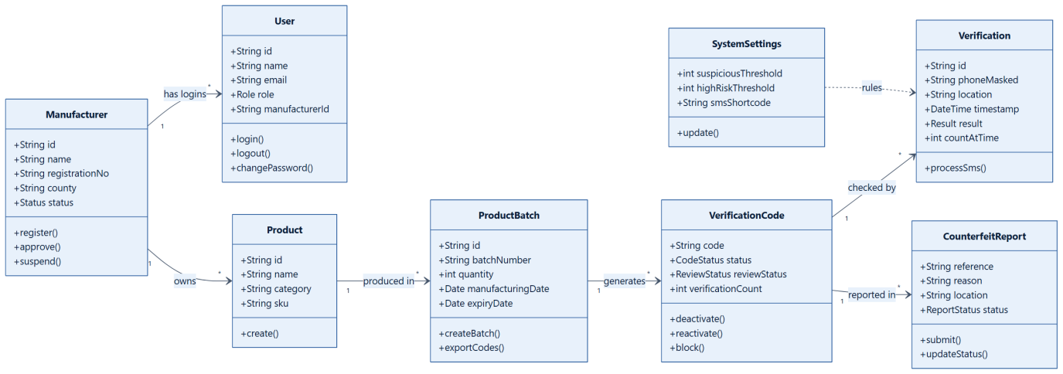
Figure 5.1 Class Diagram

5.2.2 Object Diagram
An object diagram shows a set of objects and their relationships at a point in time; it is a snapshot of instances of the classes in a class diagram and is used to illustrate a structure with concrete examples (Booch, Rumbaugh & Jacobson, 2005; Fowler, 2004). Figure 5.2 shows the objects that exist after a code has been checked more often than the suspicious threshold. The manufacturer acme owns the product pcm, produced in batch b07, which generated the code c1. The first check (v1) returned a verified result, while the fourth check (v4), from a different town, exceeded the threshold of three set in settings, so the code's review status became suspicious and a customer filed report rpt12 against it. The data shown are illustrative.
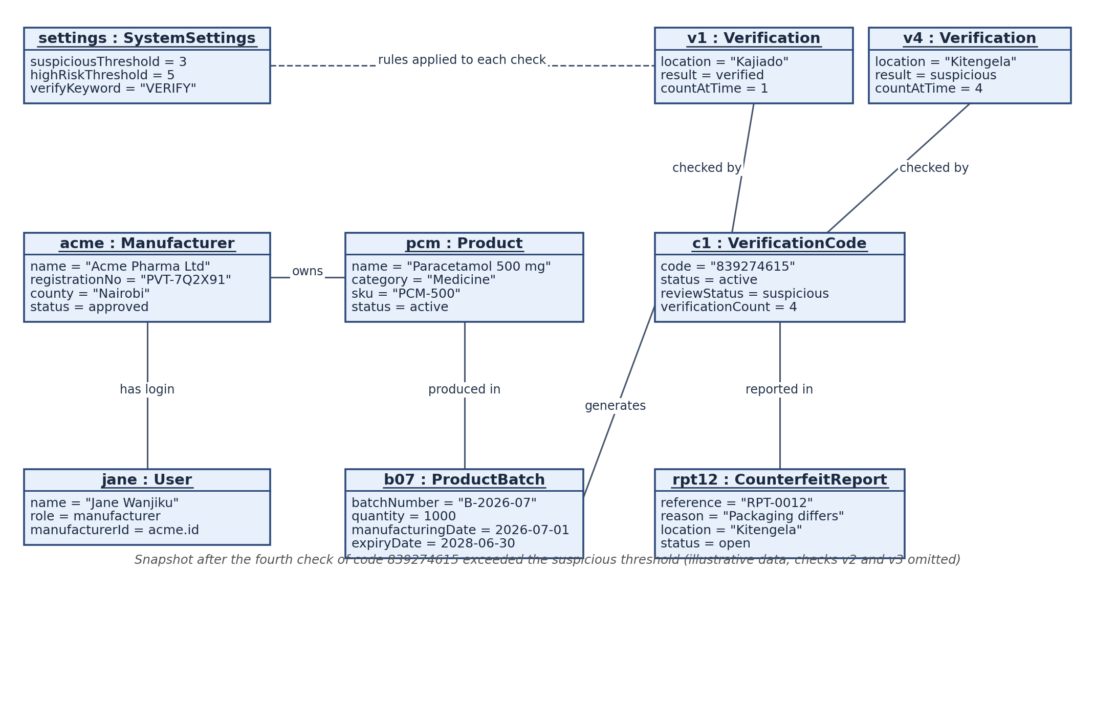
Figure 5.2 Object Diagram of a Suspicious Code

5.2.3 Component Diagram
A component diagram shows the organisation of, and dependencies among, a set of components, where a component is a modular, replaceable part of a system that provides and requires interfaces (Object Management Group, 2017; Booch, Rumbaugh & Jacobson, 2005). Figure 5.3 shows the two subsystems of the system. In the web application, the Manufacturer App, Admin Dashboard and SMS Simulator use a Supabase client, which requires the authentication, functions and data interfaces provided by the Supabase backend. In the backend, the sms-incoming Edge Function receives messages from the Africa's Talking gateway and calls the process_sms database function, and replies are returned to the customer's phone through the gateway.
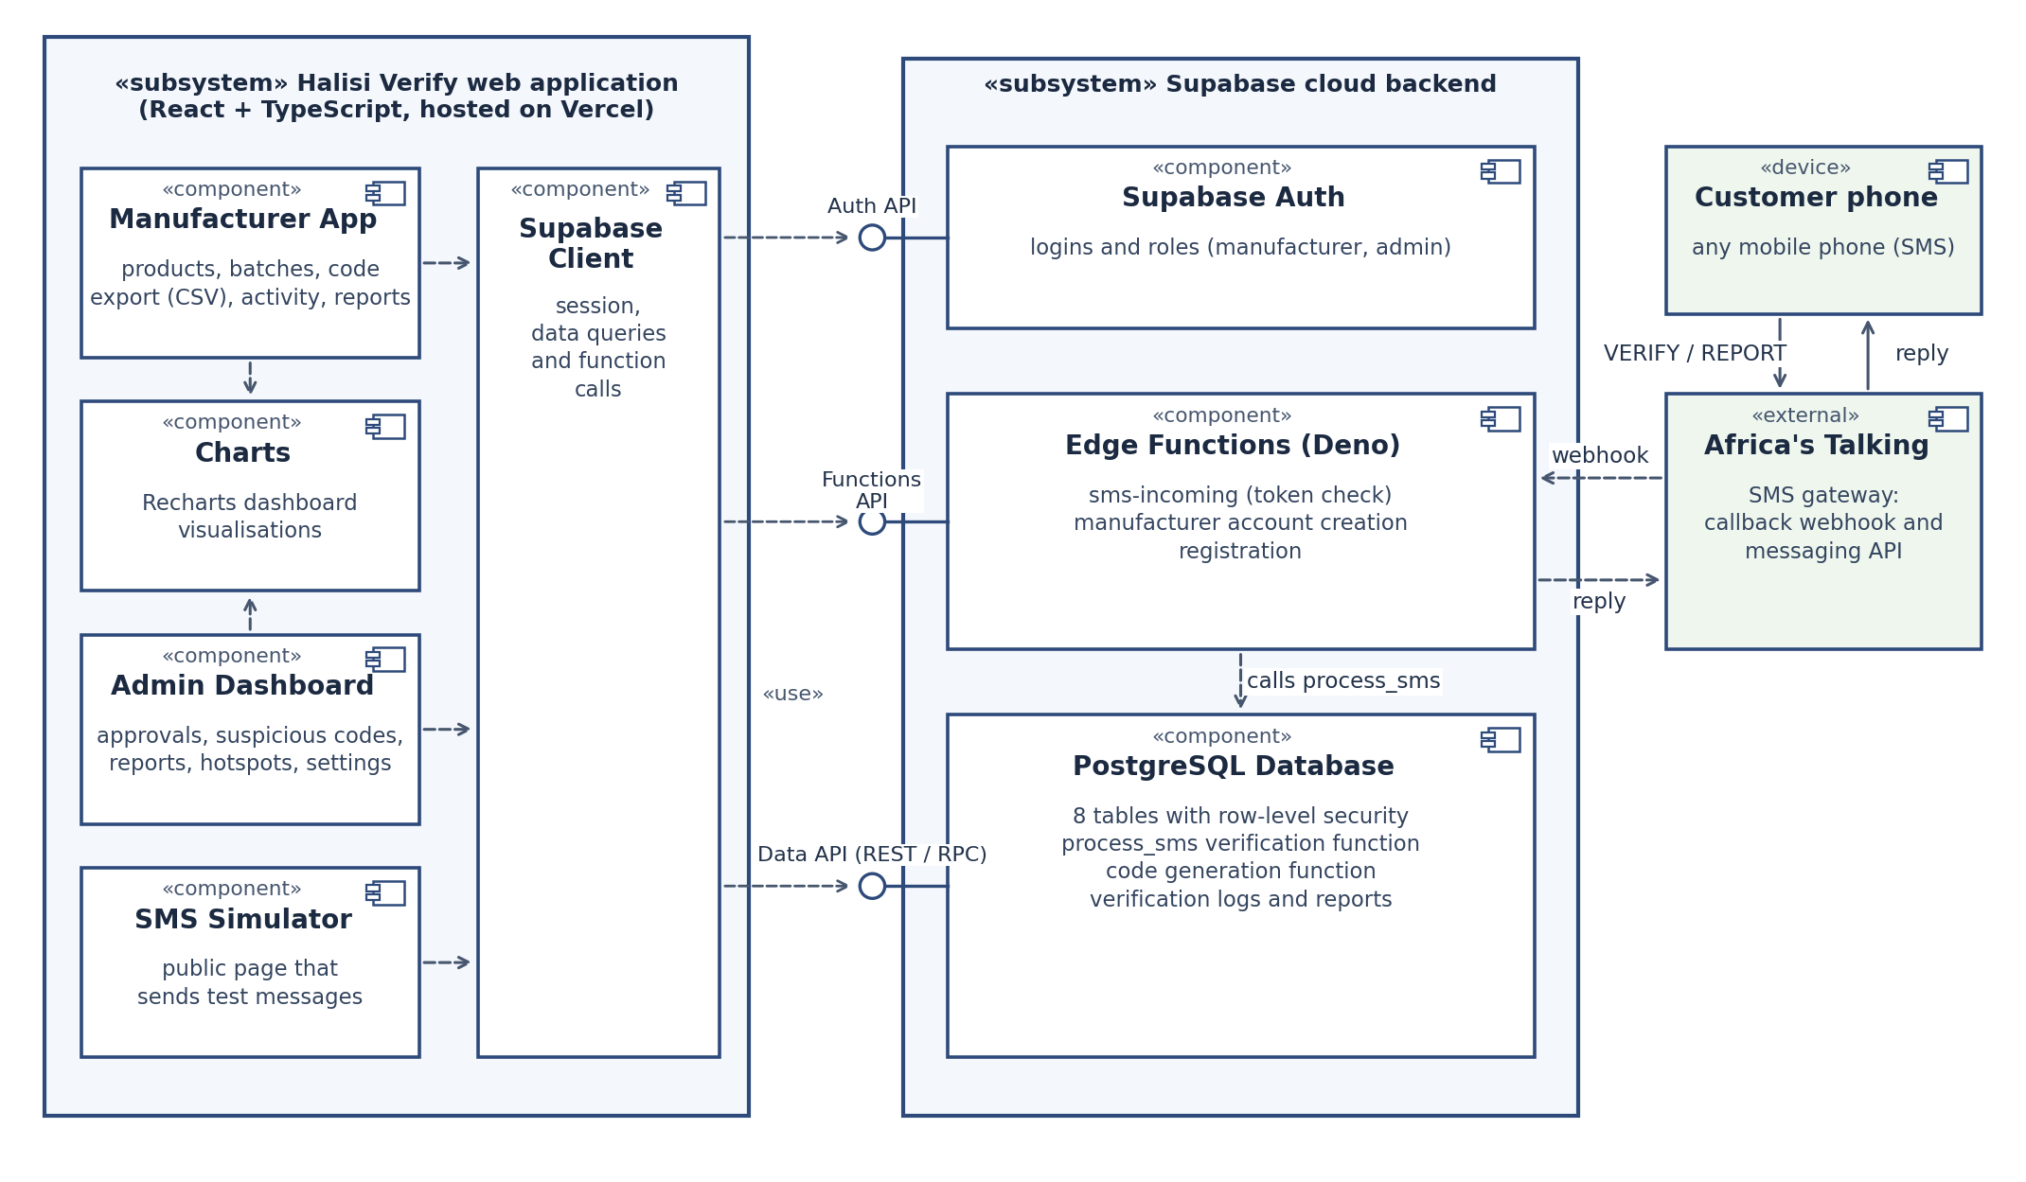
Figure 5.3 Component Diagram

5.3 Behavioral Diagrams
Behaviour diagrams show the dynamic behaviour of the objects in a system, including their interactions and changes of state over time (Object Management Group, 2017). Three behavioural diagrams are presented: the use case, sequence and activity diagrams, which show how the system responds to users and events over time.

5.3.1 Use Case Diagram
A use case diagram shows a set of use cases and actors and their relationships, and is used to model the functional requirements of a system from the point of view of its users (Booch, Rumbaugh & Jacobson, 2005).
The system has three actors. The Customer verifies a product by SMS and reports a suspected fake. The Manufacturer registers a company, logs in, creates product batches, exports and deactivates codes, and views verification activity and reports. The Administrator logs in, adds and approves manufacturers, creates manufacturer logins, views verification logs, investigates and blocks suspicious codes, manages counterfeit reports, views hotspots and configures settings. The SMS gateway is an external system that carries messages between the customer and the system.
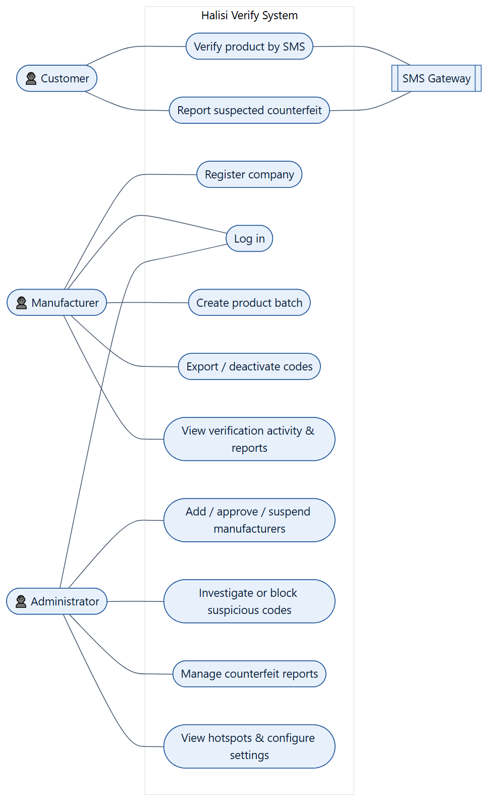
Figure 5.4 Use Case Diagram

5.3.2 Sequence Diagram
A sequence diagram is an interaction diagram that emphasises the time ordering of the messages exchanged between objects (Booch, Rumbaugh & Jacobson, 2005).
The sequence of a product verification by SMS is as follows:
- The customer sends “VERIFY <code>” to the shortcode.
- The SMS gateway forwards the message to the sms-incoming Edge Function, including a secret token in the address.
- The Edge Function checks the token and calls the database function process_sms.
- The database function looks up the code. If it does not exist, it records an invalid check; if the code is deactivated, it records the check and returns a warning; otherwise it increases the code’s check count, compares the count with the threshold and records a verified or suspicious result.
- The function returns the reply text to the Edge Function.
- The Edge Function sends the reply to the customer through the gateway’s messaging API.
- The new verification appears on the manufacturer’s and administrator’s dashboards.
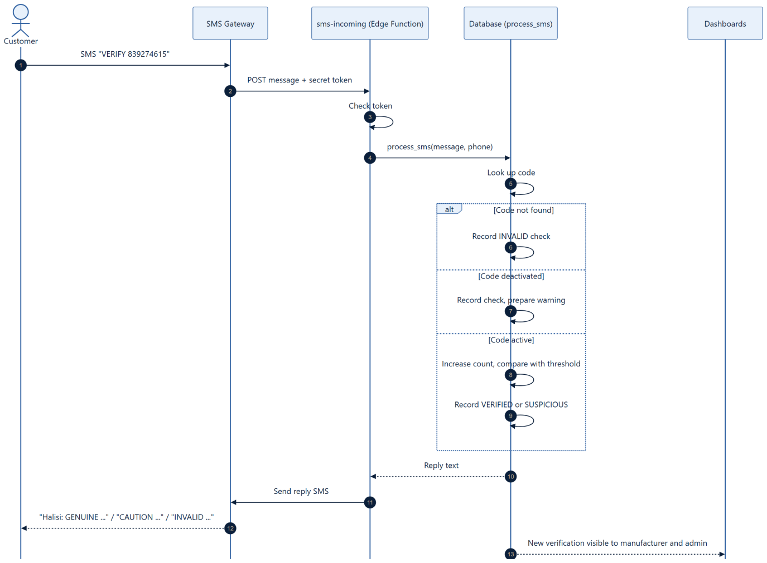
Figure 5.5 Sequence Diagram for SMS Verification

5.3.3 Activity Diagram
An activity diagram shows the flow from activity to activity within a process, including decisions and parallel paths, and is used to model workflows (Booch, Rumbaugh & Jacobson, 2005).
The main activity flow starts when a manufacturer registers. The administrator reviews and approves the company. The manufacturer then creates a batch, the system generates the codes, and the manufacturer exports them for printing. Once products are on sale, customers verify codes by SMS; the system decides the result, replies and records the check. Codes that exceed the threshold are flagged, and the administrator decides whether to investigate, block or clear them. Customer reports follow a parallel flow from submission to resolution.
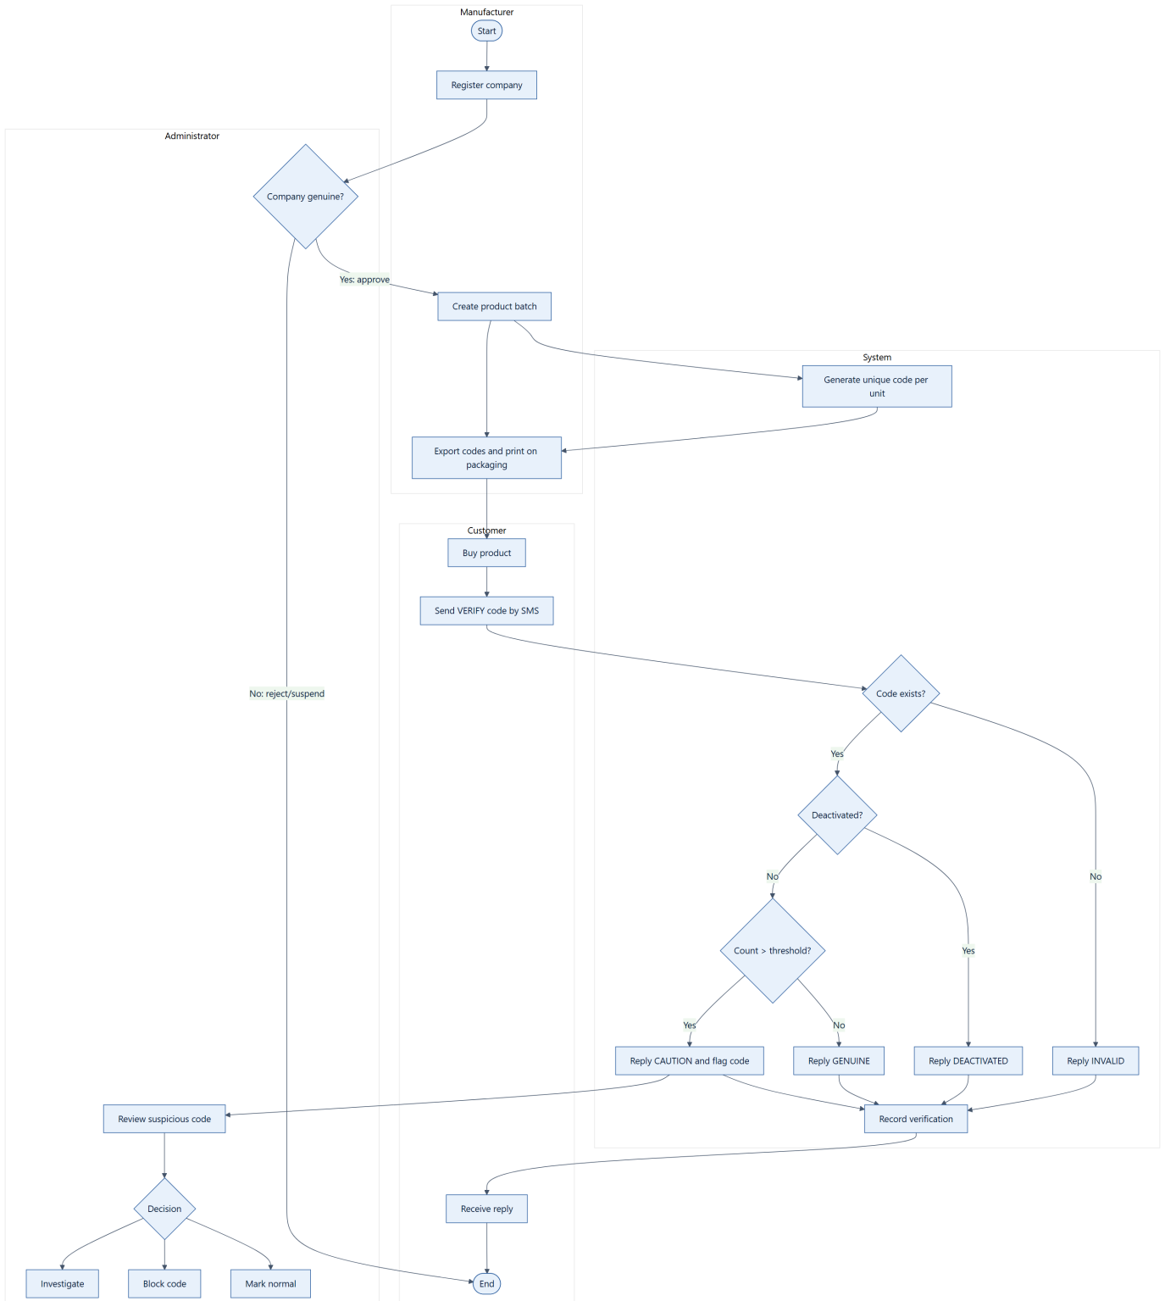
Figure 5.6 Activity Diagram

5.4 Database Schema
A database schema is the description of a database, specified during design, that defines its tables, attributes, data types and constraints (Elmasri & Navathe, 2016). The schema was designed from an entity relationship model. The entity relationship diagram, introduced by Chen (1976), represents entities, their attributes and the relationships between them; it is a data-modelling notation rather than one of the UML diagram types (Elmasri & Navathe, 2016), and it is therefore presented here as part of the database design rather than among the UML structural diagrams.

5.4.1 Entity Relationship Diagram (ERD)
The ERD shows the entities stored in the database and how they relate. A manufacturer owns many products; each product has many batches; each batch has many verification codes; each code can have many verification records and reports. Each login profile is linked to one authentication account and, for manufacturers, to one manufacturer. Verification records keep the code even when it does not exist in the system, so that attempts with fake codes can also be analysed.
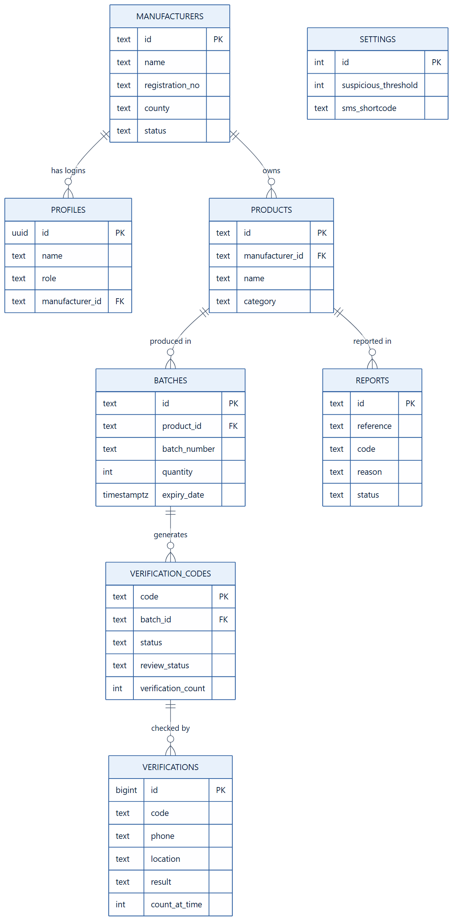
Figure 5.7 Entity Relationship Diagram

5.4.2 Physical Database Schema
The database was implemented in PostgreSQL on Supabase. Table 5.2 summarises the tables and their main fields. Row-level security is enabled on every table so that manufacturers can only read their own rows, administrators can read all rows, and visitors who are not logged in can read nothing except the public settings.
Table | Main fields | Purpose
manufacturers | id, name, registration_no, contact_person, email, phone, county, address, industry, status, joined_at | Registered companies and their approval status
profiles | id (auth user), name, email, role, manufacturer_id, title | Links each login to its role and company
products | id, manufacturer_id, name, category, description, sku, status | Products owned by manufacturers
batches | id, product_id, manufacturer_id, batch_number, quantity, manufacturing_date, expiry_date, status | Production runs
verification_codes | code (9 digits), batch_id, product_id, manufacturer_id, status, review_status, verification_count | One unique code per unit
verifications | id, code, product_id, phone (masked), location, created_at, result, count_at_time, channel | Every customer check
reports | id, reference, code, product_name, reason, description, location, status, notes | Counterfeit reports from customers
settings | suspicious_threshold, high_risk_threshold, sms_shortcode, verify_keyword, report_keyword | System rules set by the administrator
Table 5.2 Database Tables
The verification rules applied by the database are summarised in Table 5.3.
Situation | Result | Reply to customer (summary)
Code not found in the system | Invalid | Code not registered; product may be fake; how to report
Code exists but has been deactivated or blocked | Deactivated | Warning not to use the product
Code exists and number of checks ≤ threshold (default 3) | Verified | Genuine, with product, batch, manufacturer and expiry date
Code exists and number of checks > threshold | Suspicious | Caution: code checked many times, may be copied; how to report
Message starts with REPORT | Report created | Thank-you message with report reference
Any other message | Help | Instructions on the correct message format
Table 5.3 SMS Verification Rules

5.5 Wireframes
A wireframe is a low-fidelity visual guide that arranges the elements of a screen, showing its structure and navigation without visual styling (Garrett, 2011).
Before development, layouts were planned for the main screens: the login and registration pages; the manufacturer dashboard, products, batches, codes, activity and reports pages; the administrator dashboard, manufacturers, verification logs, suspicious activity, reports, hotspots and settings pages; and the SMS simulator. The final interfaces are shown in Chapter Six.
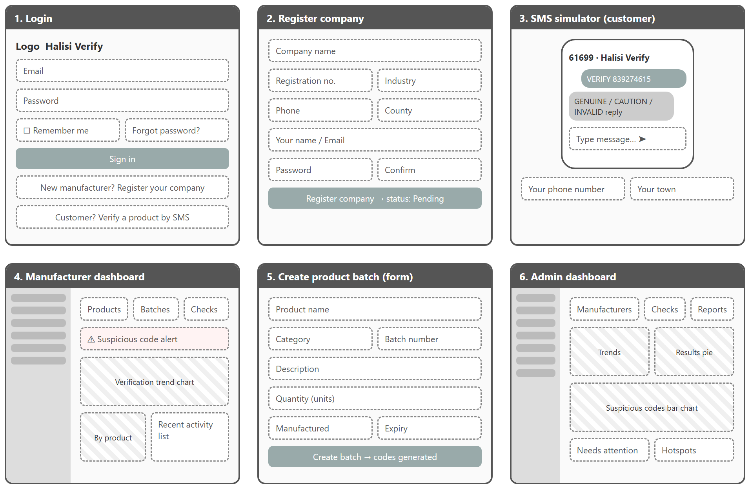
Figure 5.8 Wireframes of the Main Screens

5.6 Summary
This chapter presented the design of the system. The class diagram defined the main classes, the object diagram illustrated them with the objects that exist when a code is flagged as suspicious, and the component diagram showed the software components and the interfaces between the web application, the Supabase backend and the SMS gateway. The use case, sequence and activity diagrams described the system's behaviour, the database schema was designed from the entity relationship diagram together with the verification rules, and the planned screen layouts were presented. Together these form the blueprint that guided the implementation described in the next chapter.

CHAPTER SIX: SYSTEM DEVELOPMENT AND IMPLEMENTATION

6.1 Introduction
This chapter describes how the design was implemented. It presents the development tools and technologies, shows the main system interfaces, and discusses the challenges met during development and how they were handled.

6.2 System Development Tools and Techniques
Table 6.1 lists the tools and technologies used.
Area | Tool / technology | Use in the project
Code editor | Visual Studio Code | Writing and managing the source code
Front end | React, TypeScript, Vite | Building the web application
Styling and charts | Tailwind CSS, Recharts, Lucide icons | Layout, visual design, dashboard charts and icons
Database | PostgreSQL (Supabase) | Storing all system data; verification and code-generation functions
Authentication and security | Supabase Auth, row-level security | Logins and role-based access to data
Server functions | Supabase Edge Functions (Deno) | Receiving SMS, creating manufacturer accounts, registration
SMS gateway | Africa’s Talking (sandbox) | Receiving customer SMS and sending replies
Hosting | Vercel | Publishing the web application
Runtime and packages | Node.js, npm | Running the development server and building the application
Table 6.1 Development Tools and Technologies

6.2.1 Integrated Development Environment (IDE)
Visual Studio Code was used as the main development environment. It provides TypeScript support with instant error highlighting, an integrated terminal for running the development server and build commands, and extensions for React and Tailwind CSS. The Vite development server reloads the application automatically when code changes, which made iterative development fast.
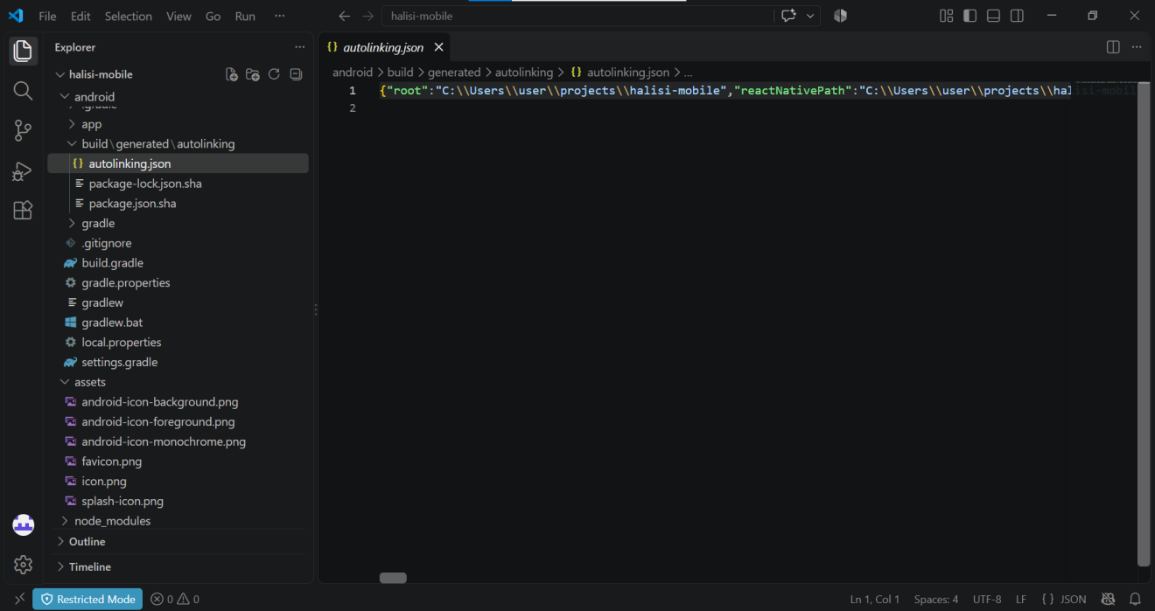
Figure 6.1 Development Environment (Visual Studio Code)

6.2.2 Front-end Development
The front end was built with React and TypeScript. The code is organised into reusable components (buttons, cards, tables, forms, dialogs and charts), pages for each role, layouts, services and type definitions. All data access goes through a single service layer, which made it possible to build the interface first with sample data and later switch to the live database without changing the pages. The interface is responsive: tables turn into cards on narrow screens, and the navigation becomes a slide-out menu on phones.

6.2.3 Database Management Tools
Supabase was used to host the PostgreSQL database, manage user authentication, store secrets and run Edge Functions. The database structure, security rules and functions were written as SQL scripts and applied through the Supabase SQL Editor. Key database functions include create_product_batch, which generates one unique nine-digit code per unit using a cryptographically secure random generator, and process_sms, which applies the verification rules in Table 5.3.
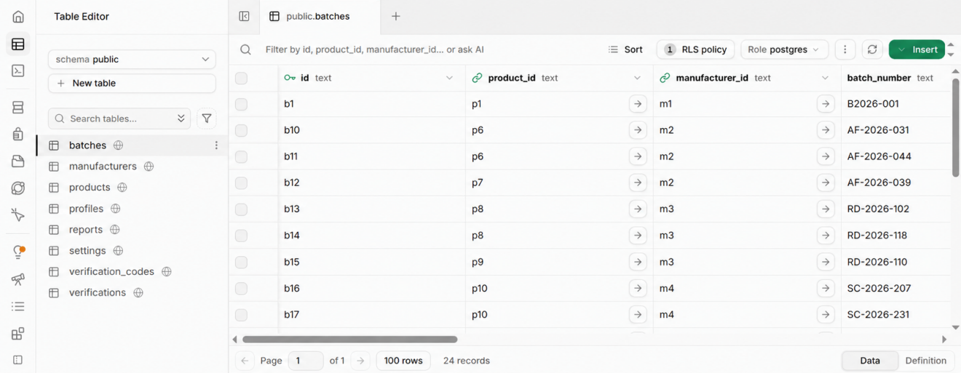
Figure 6.2 Supabase Project Dashboard
Africa’s Talking was selected as the SMS gateway. A sandbox shortcode was created, and the incoming-message callback was set to the address of the sms-incoming Edge Function, protected by a secret token. The web application was deployed on Vercel and is available at https://sms-verify-seven.vercel.app.

6.3 System Interfaces
This section presents the main interfaces of the system.
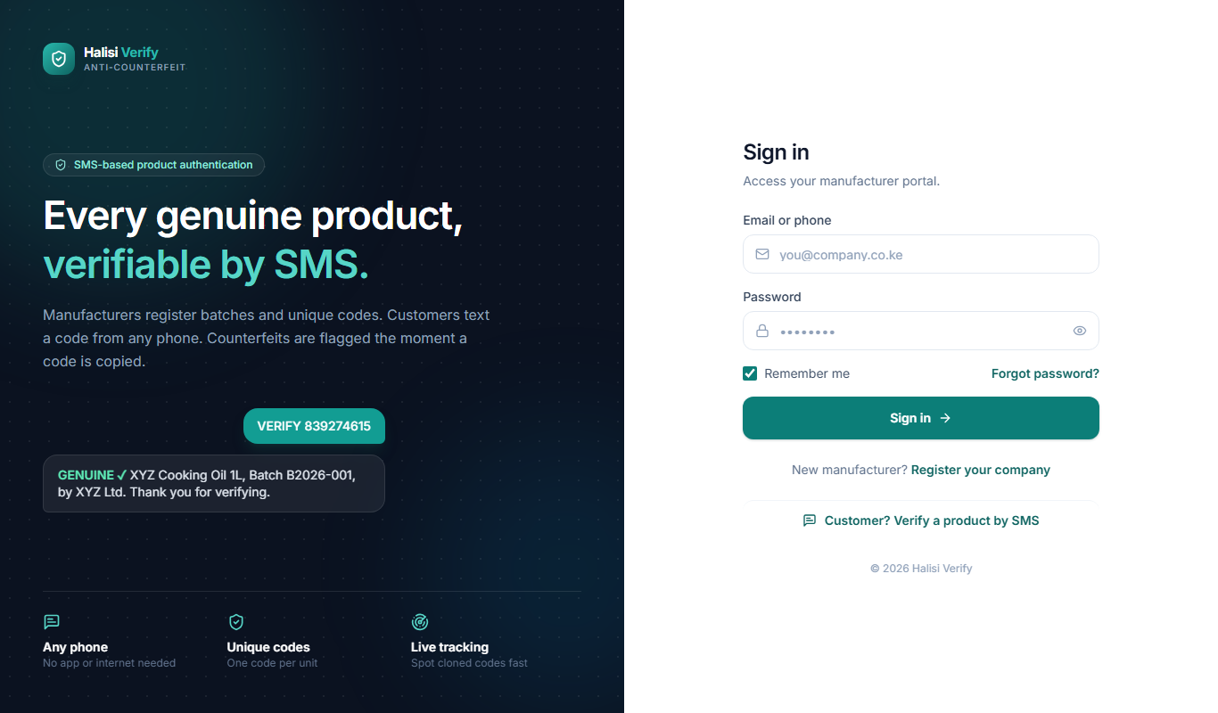
Figure 6.3 Login Page
The login page is shared by manufacturers and the administrator. After signing in, each user is taken to the dashboard for their role. The page does not show any administrator option, and it links to company registration and to the public SMS verification page.
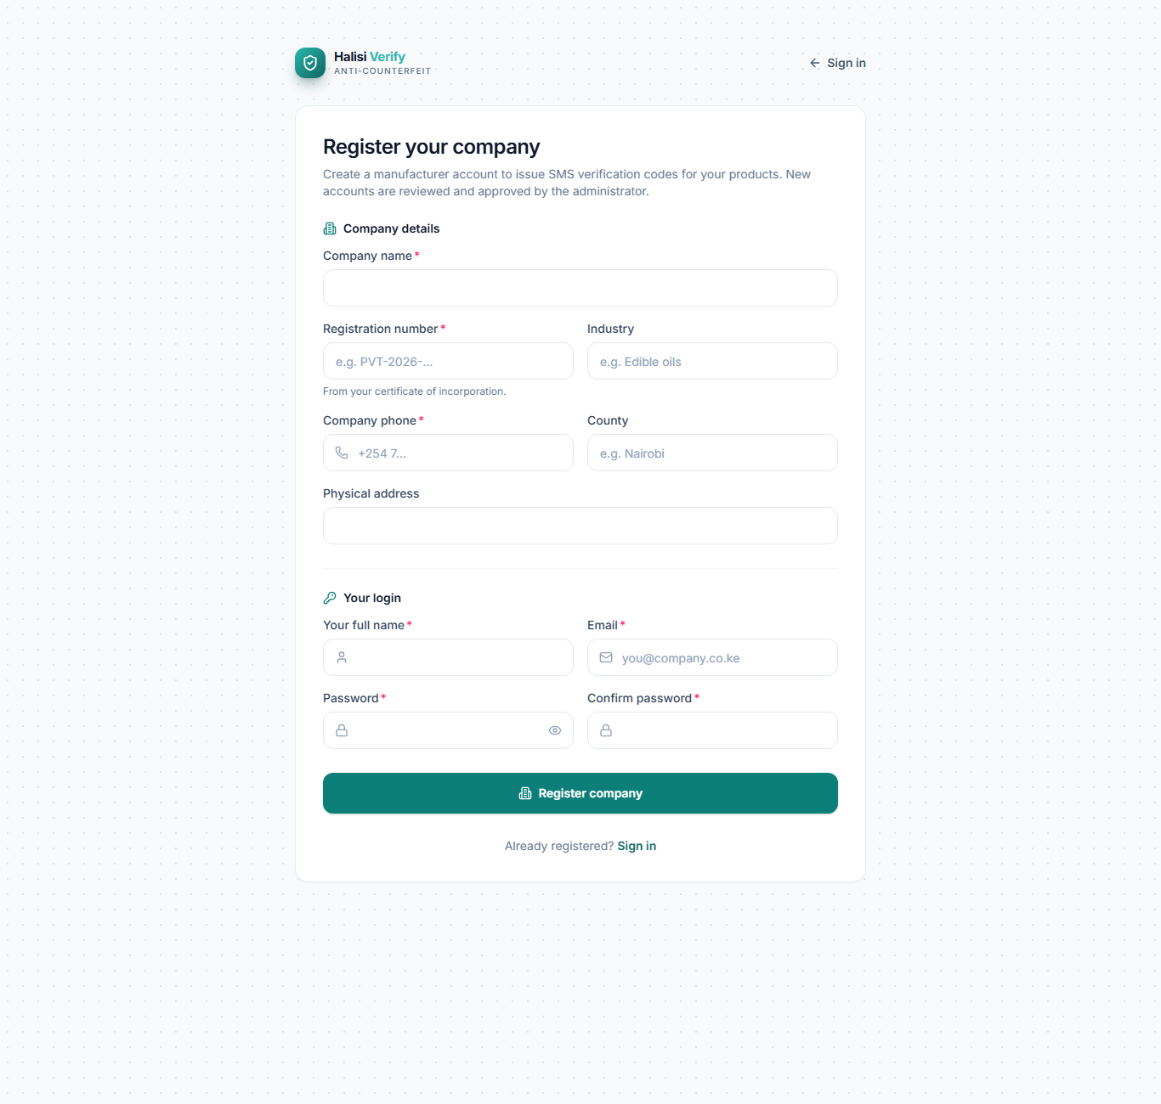
Figure 6.4 Manufacturer Registration Page
New manufacturers register their company and create their own login. The account starts as pending, and batch creation is unlocked only after the administrator approves the company.
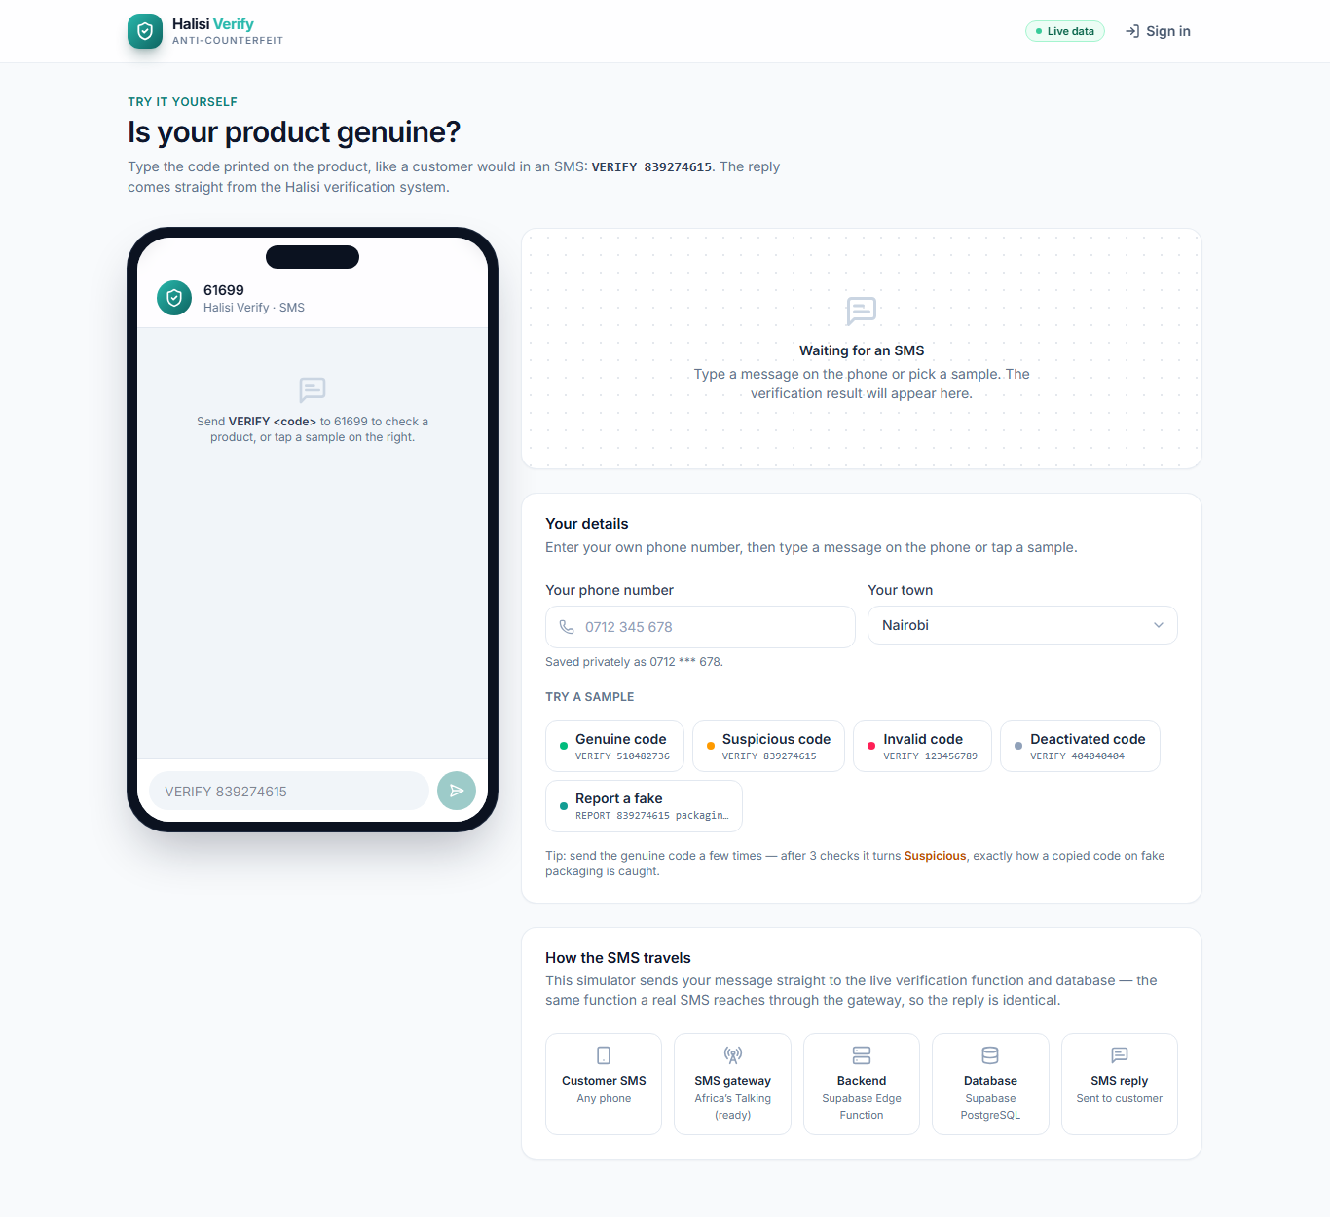
Figure 6.5 SMS Verification Simulator
The SMS simulator lets anyone type a message such as “VERIFY 839274615” on a phone-style screen after entering their own phone number. The message is processed by the same database function used for real SMS messages, and the check is recorded on the dashboards.
The following screenshots of the manufacturer and administrator portals were taken with the system’s demonstration data, which consists of fictional companies and products.
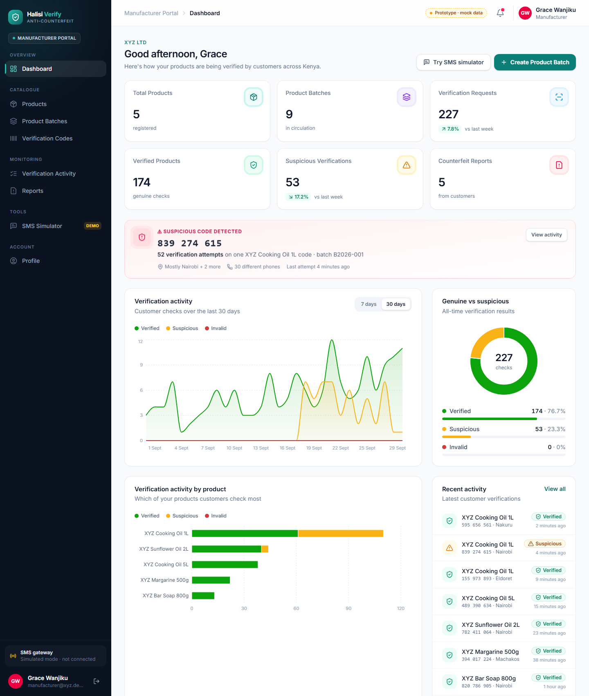
Figure 6.6 Manufacturer Dashboard
The manufacturer dashboard summarises the company’s products, batches and verifications. It shows a warning when one of the company’s codes has been checked too many times, charts of verification activity, and a feed of recent checks. Each statistic card opens the matching detailed page.
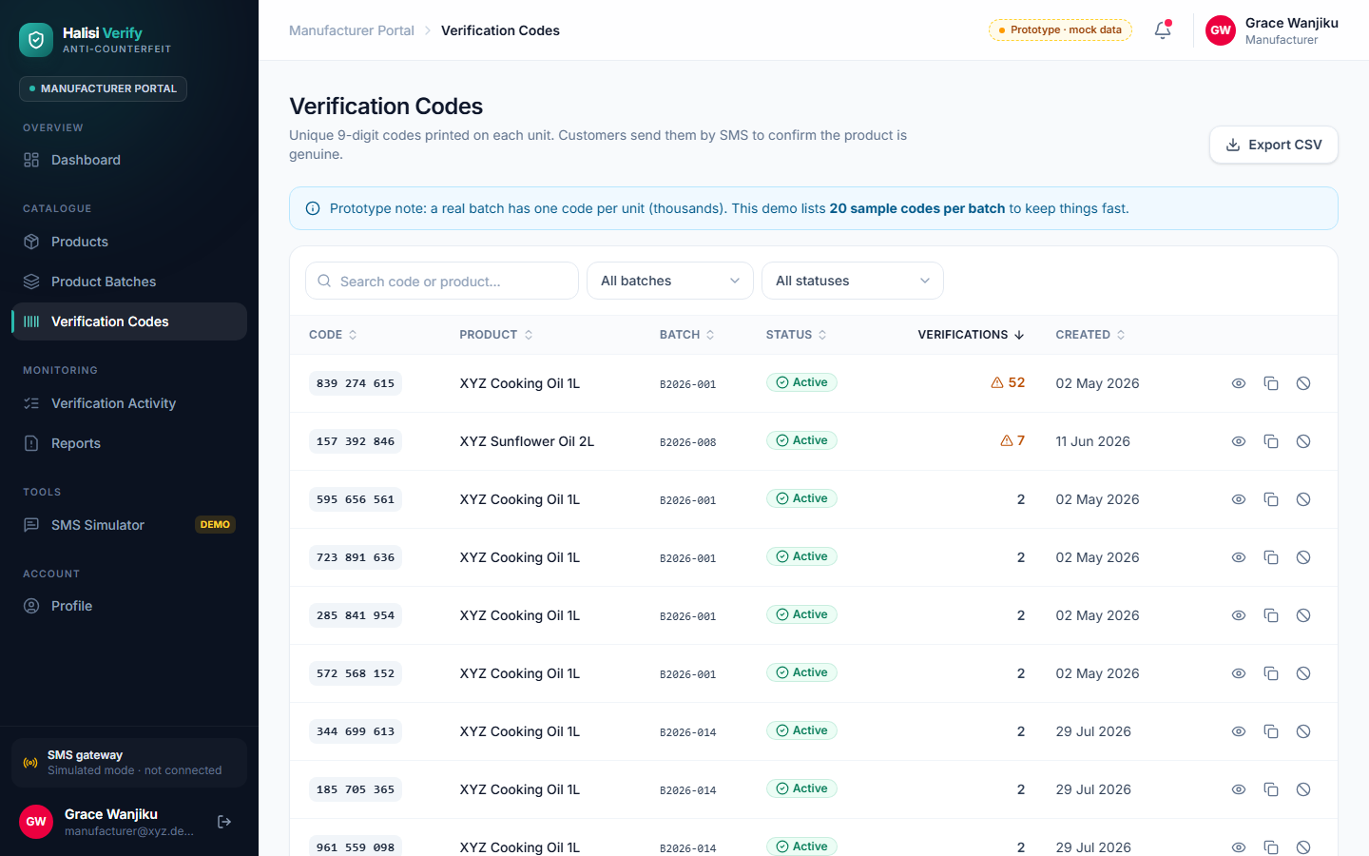
Figure 6.7 Verification Codes Page
The Verification Codes page lists each code with its product, batch, status and number of checks. Codes checked more often than allowed are marked, and the manufacturer can view a code’s history, copy it, export codes to CSV or deactivate a code.
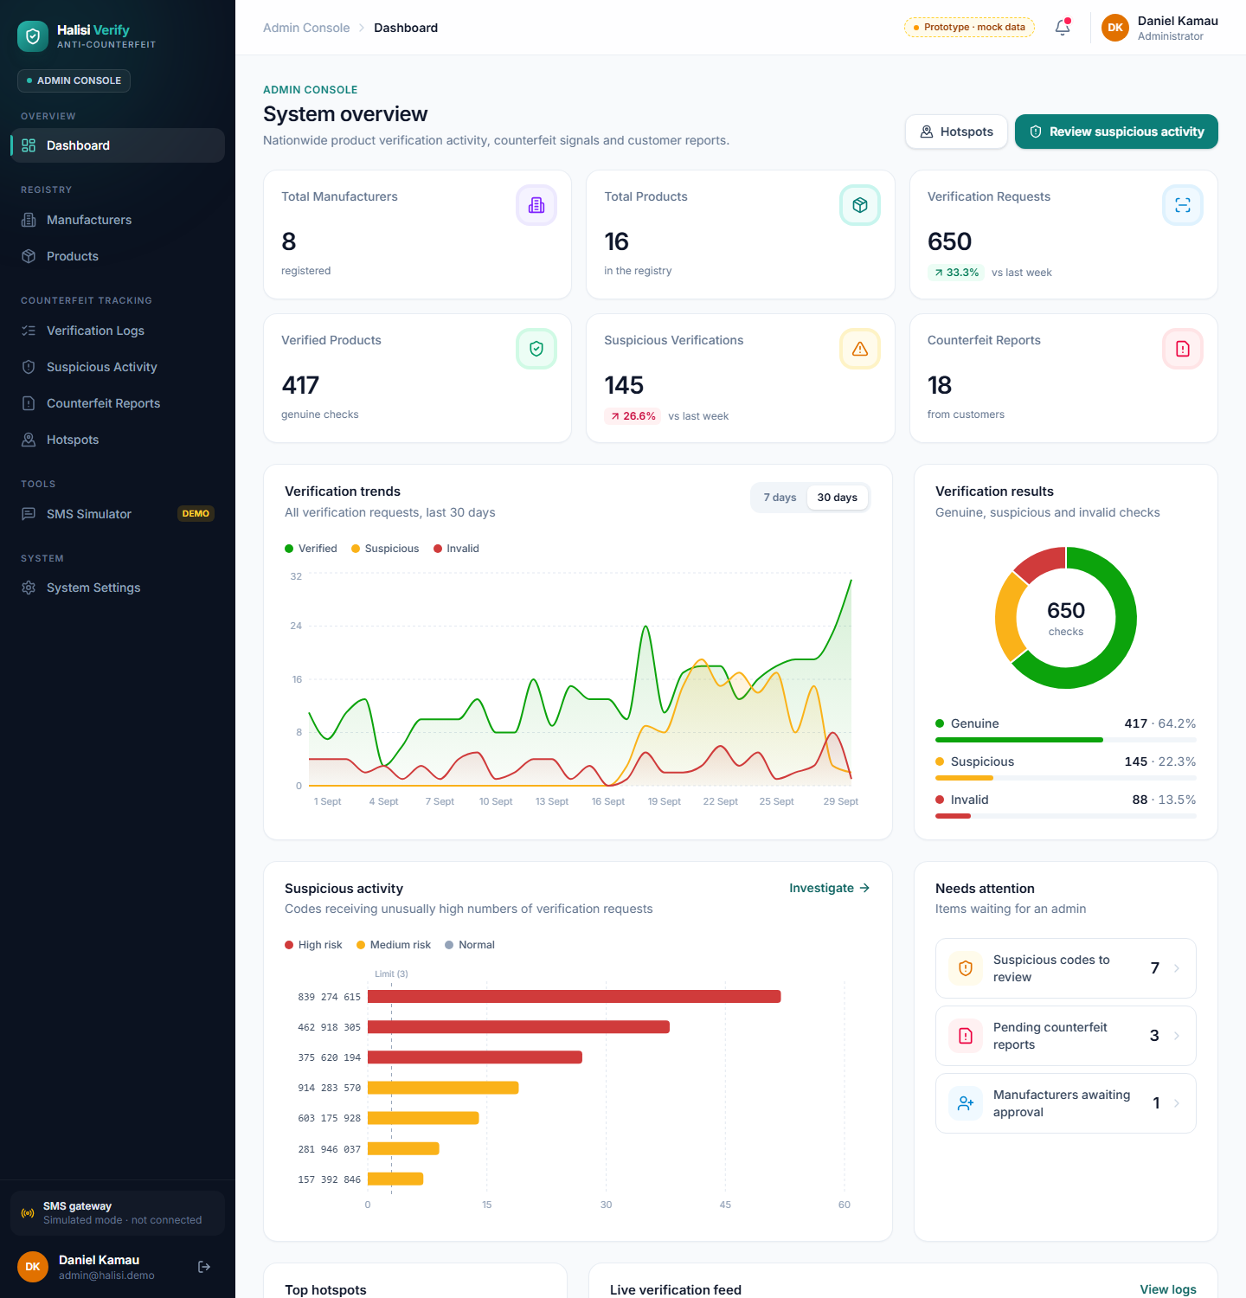
Figure 6.8 Admin Dashboard
The administrator’s dashboard gives a system-wide view: totals of manufacturers, products, verifications and reports; verification trends; the share of genuine, suspicious and invalid checks; the codes with the most checks; and items that need attention.
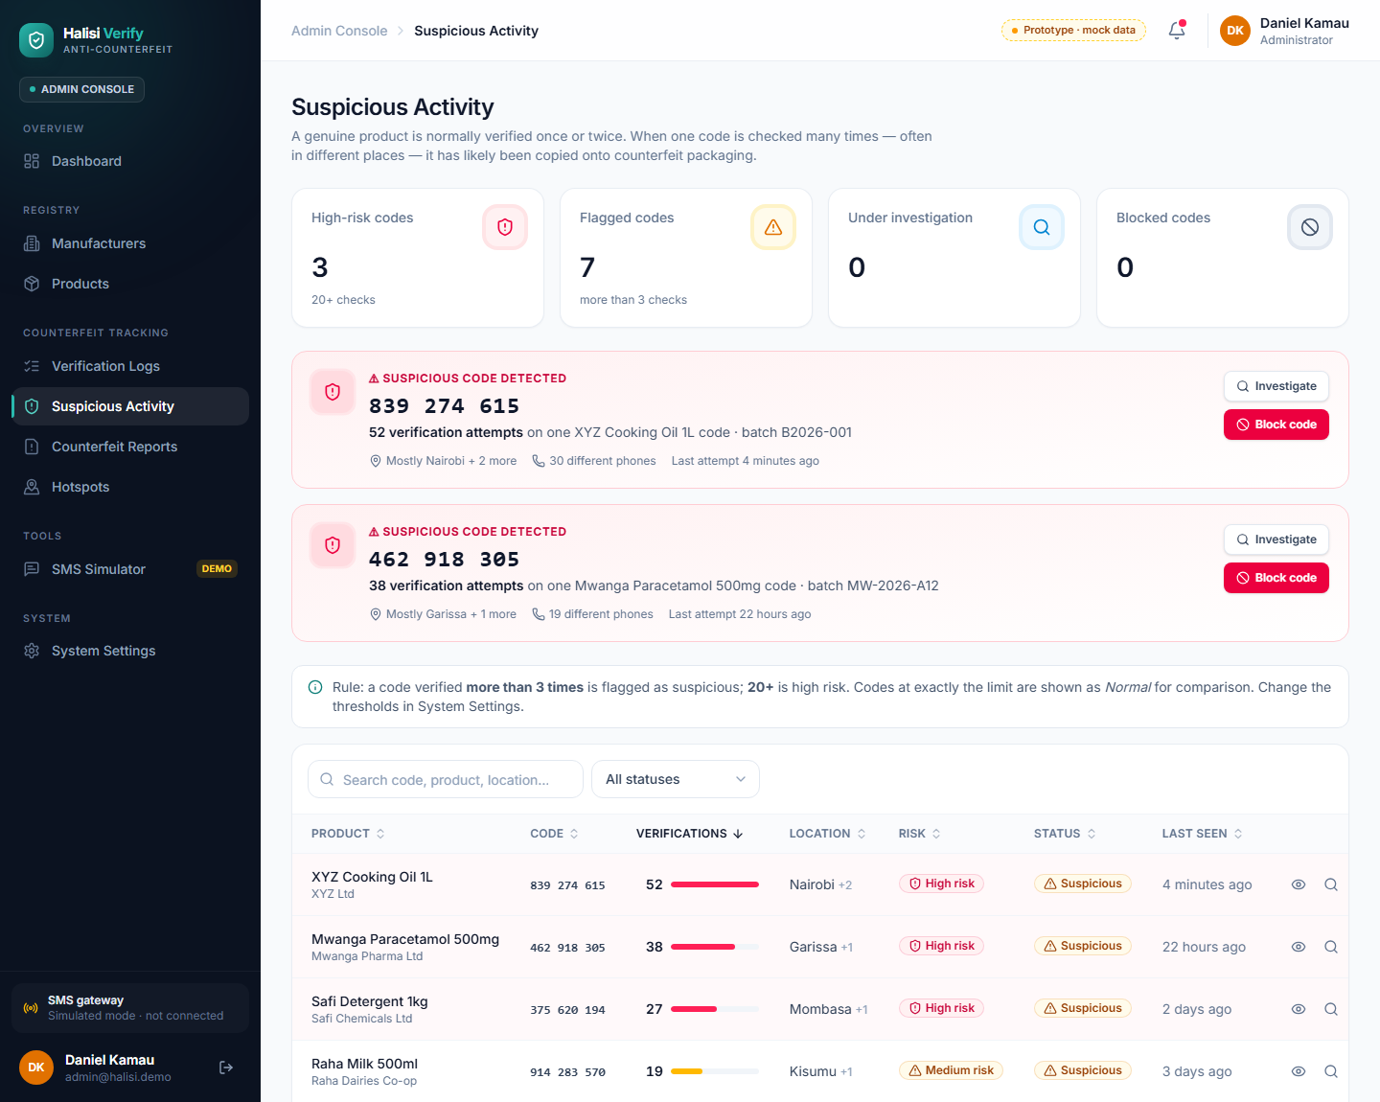
Figure 6.9 Suspicious Activity Page
The Suspicious Activity page highlights codes that have been checked unusually often, with the number of checks, locations and number of different phones. The administrator can open an investigation, block a code or mark it as normal.
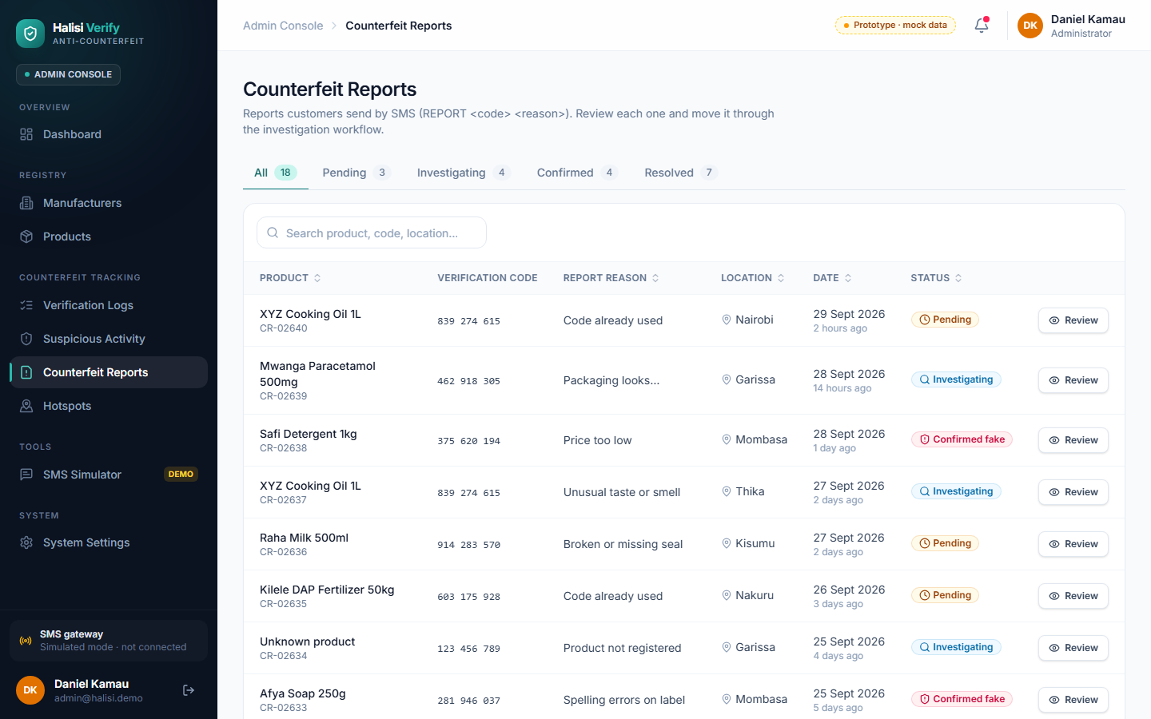
Figure 6.10 Counterfeit Reports Page
Counterfeit reports sent by customers are listed with their product, code, reason, location and status. The administrator reviews each report and moves it through the statuses pending, investigating, confirmed and resolved.
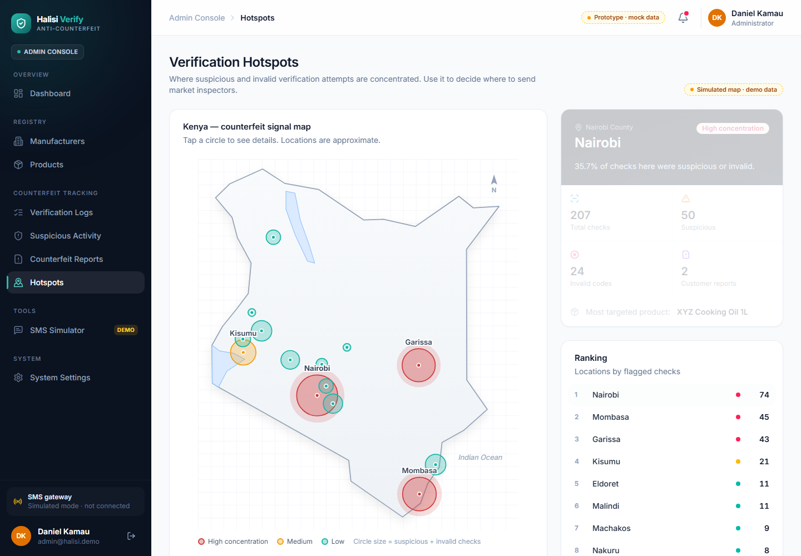
Figure 6.11 Verification Hotspots Page
The Hotspots page places Kenyan towns on a simplified map. Larger and redder circles indicate more suspicious and invalid checks, helping the administrator decide where inspections are most needed.
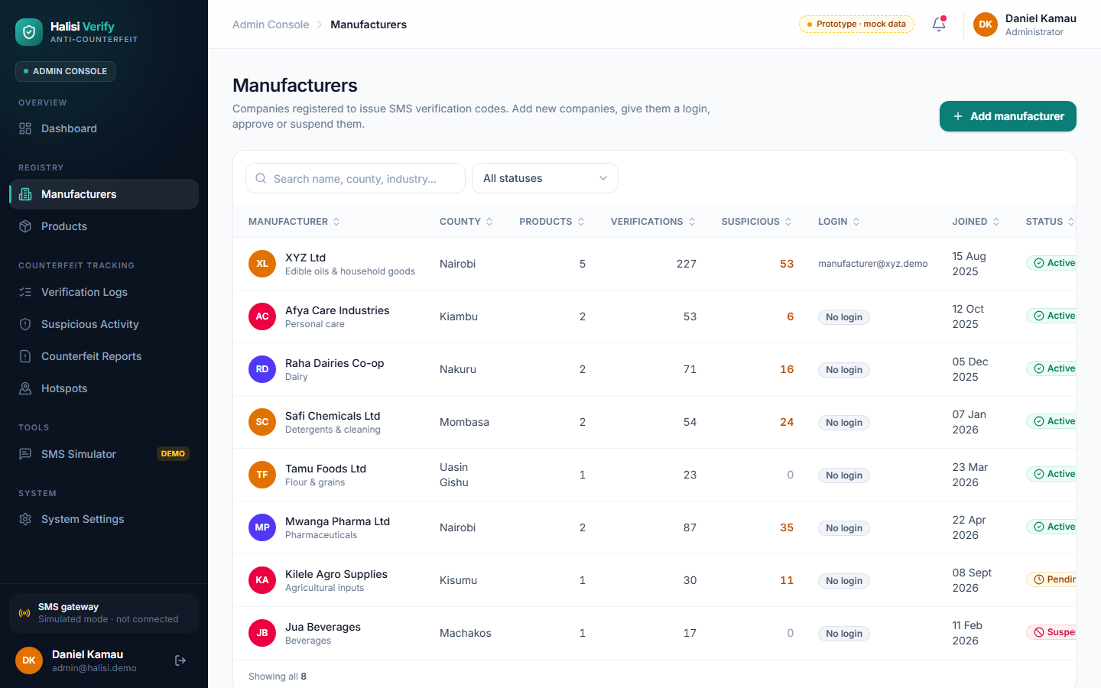
Figure 6.12 Manufacturers Page
The Manufacturers page lets the administrator add a company with its login, create a login for an existing company, and approve, suspend or reactivate manufacturers.

6.4 Challenges Encountered During Development

6.4.1 Technical Complexities
Designing the security rules so that manufacturers could only see their own data, while the verification function could still update check counts on their behalf, required careful work. This was solved by combining row-level security policies with database triggers that block manufacturers from changing counts or administrator decisions, and by running the verification logic in a trusted database function. Another challenge was ensuring that every generated code is unique; the code-generation function repeats any rare duplicates until the required number of unique codes has been produced.
The most significant external challenge was activating the Africa’s Talking account. The sandbox could be used to create a shortcode and set the callback address, but generating an API key required account email verification, and the verification email did not arrive despite repeated attempts and a request to the provider’s support team. The provider’s web phone simulator was also unreachable at the time of testing. As a result, the incoming SMS function was tested with requests in the gateway’s own format, and the demonstration uses the built-in SMS simulator, which runs the same verification logic.

6.4.2 User Adoption and Resistance
Customers may be unfamiliar with verifying products by SMS, and manufacturers may hesitate to adopt a new system. To encourage adoption, SMS commands were kept short (for example “VERIFY <code>” and “REPORT <code> <reason>”), replies were written in plain language, and a message in the wrong format receives a help reply explaining the correct format. Manufacturers can register themselves and export their codes as a CSV file for printing, which reduces the effort needed to join. During user acceptance testing, participants asked for replies that state clearly whether a product is genuine, suspicious or unrecognised, and for short messages, which guides the wording of the SMS replies.

6.4.3 Economic Constraints
The project had no budget for paid services. Free tiers of Supabase, Vercel and the Africa’s Talking sandbox were therefore used. These tiers have limits: for example, the prototype restricts each batch to 10,000 codes, and a free Supabase project is paused after a period of inactivity and must be restored from its dashboard.

6.4.4 Continuous Updates and Support
Several features were refined after review, including clickable dashboard statistics, allowing customers to type their own phone number in the simulator, removing demonstration accounts from the login page, and adding manufacturer registration. Because the live site is redeployed after each change, maintaining the system requires disciplined testing before each deployment.

6.5 Summary
This chapter described the implementation of the system using React, TypeScript, Supabase, Africa’s Talking and Vercel, presented its main interfaces, and discussed the technical, external and economic challenges encountered and the ways they were addressed.

CHAPTER SEVEN: SYSTEM TESTING AND DEPLOYMENT

7.1 Introduction
This chapter describes how the system was tested and deployed. Testing aimed to confirm that the verification logic, access control and user interfaces work correctly, while deployment made the system available on the internet without depending on the developer’s computer.

7.2 System Testing and Validation
Three levels of testing were carried out: automated unit tests of the database functions and security rules, functional tests of the deployed server functions, and user interface checks. The results reported below are from tests that were actually run during development.

7.2.1 Unit Tests
The database schema, demonstration data and functions were loaded into PGlite, a version of PostgreSQL that runs inside Node.js, and 32 automated test cases were run against them, simulating anonymous visitors, a manufacturer, an administrator and the SMS gateway. All 32 passed. Table 7.1 shows a selection.
ID | Module | Test case | Expected result | Actual result | Status
UT01 | SMS verification | First check of a registered code | Verified, genuine reply | As expected | Pass
UT02 | SMS verification | Fourth check of the same code | Suspicious (threshold 3) | As expected | Pass
UT03 | SMS verification | Code not in the system | Invalid | As expected | Pass
UT04 | SMS verification | Code from a recalled batch | Deactivated warning | As expected | Pass
UT05 | Reporting | “REPORT <code> <reason>” | Report created with reference | As expected | Pass
UT06 | Abuse protection | More than 10 messages in a minute from one number | Rate-limit reply | As expected | Pass
UT07 | Code generation | Create a batch of 1,500 units | 1,500 unique nine-digit codes | As expected | Pass
UT08 | Batch creation | Reuse an existing batch number | Rejected | As expected | Pass
UT09 | Access control | Manufacturer reads verifications | Only own records returned | As expected | Pass
UT10 | Access control | Manufacturer edits a check count | Change blocked | As expected | Pass
UT11 | Access control | Visitor (not logged in) reads data | Nothing except settings | As expected | Pass
UT12 | Privacy | Phone number stored | Masked, e.g. 0712 *** 678 | As expected | Pass
Table 7.1 Unit Testing (selection of 32 automated tests)

7.2.2 Functional Testing
Functional tests were run against the deployed Supabase functions and database over the internet. Table 7.2 summarises them.
ID | Feature | Test scenario | Expected outcome | Actual outcome | Status
FT01 | SMS webhook security | Send an SMS request without the secret token | Rejected (401) | Rejected (401) | Pass
FT02 | Incoming SMS | Send “VERIFY 510482736” in Africa’s Talking format with the token | Accepted; check saved as channel SMS | Accepted; saved as SMS, phone masked | Pass
FT03 | Public simulator | Verify a code through the public API | Genuine reply with product details | Genuine reply returned | Pass
FT04 | Admin account function | Call the admin function without an admin login | Rejected | Rejected (401) | Pass
FT05 | Registration | Submit without a registration number | Rejected with message | Rejected (400) | Pass
FT06 | Registration | Register an existing company name | Rejected as duplicate | Rejected (409) | Pass
FT07 | Registration | Bot fills hidden trap field | No account created | No record created | Pass
FT08 | SMS reply | Send reply through Africa’s Talking | Reply delivered | Refused: API key not yet available | Blocked (external)
Table 7.2 Functional Testing

7.2.3 User Interface (UI) Testing
The interface was checked by type-checking and building the application, and by capturing screenshots with a headless browser at desktop (1440 pixels) and phone (375 pixels) widths. Problems found were fixed and re-checked. User acceptance testing was then carried out with five participants (three consumers and two retailers). Using the SMS simulator, they entered product codes, verified products, read the verification replies and reported a suspicious product. Four of the five completed all tasks without assistance. Participants found the verification process simple and easy to understand, and suggested that replies should state clearly whether a product is genuine, suspicious or unrecognised, and that messages should be kept short.
ID | UI element | Test scenario | Expected result | Actual result | Status
UI01 | Whole application | Type check and production build | No errors | No errors | Pass
UI02 | Dashboards | Layout at desktop width | Cards, charts and tables aligned | As expected after fixing chart rendering | Pass
UI03 | All pages | Layout at phone width (375 px) | No horizontal overflow | As expected | Pass
UI04 | Code columns | Long codes in narrow columns | Codes stay on one line | Fixed, then as expected | Pass
UI05 | Hotspot map | Town labels near each other | Labels readable, not overlapping | Fixed, then as expected | Pass
UI06 | Login page | Check for administrator hints | No admin option shown | As expected | Pass
Table 7.3 User Interface Testing

7.3 Testing Results
Table 7.4 summarises the results. All automated and interface tests passed. One functional test could not pass because the SMS provider had not activated the account, which is outside the system’s control and is recorded as a limitation.
Testing type | Test cases | Passed | Failed | Blocked (external) | Success rate
Unit (automated database tests) | 32 | 32 | 0 | 0 | 100%
Functional (deployed functions) | 8 | 7 | 0 | 1 | 100% of executable tests
User interface checks | 6 | 6 | 0 | 0 | 100%
User acceptance testing (participants) | 5 | 4 | 1 (needed help) | — | 80%
Table 7.4 Testing Results

7.4 System Deployment
The system was deployed to cloud services so that it is available at all times:
- Database and server functions: Supabase (PostgreSQL database, authentication, and three Edge Functions: sms-incoming, admin-users and register-manufacturer).
- Web application: Vercel, at https://sms-verify-seven.vercel.app, with the login page at /login, registration at /register and the public SMS simulator at /sms.
- SMS gateway: Africa’s Talking sandbox shortcode configured with the callback address of the sms-incoming function; replies pending account activation.

7.4.1 Current Deployment Methods
Users access the system through a web browser on a computer or phone; no installation is needed. Manufacturers either register themselves and wait for approval, or receive a login created by the administrator. Customers can verify products through the public simulator page, and by SMS once the shortcode is live.

7.4.2 Future Deployment Plans
To improve accessibility, scalability and adoption of the system, the following deployment strategies are planned:
- Live SMS shortcode: activate a production Africa’s Talking account and shortcode so that customers can verify products from any phone and receive replies.
- USSD channel: add a USSD menu as an alternative to SMS commands.
- Custom domain and paid plans: move to a custom domain and paid hosting tiers to remove free-tier limits.
These future deployment strategies aim to expand the system’s reach to every mobile phone user and support its long-term sustainability.

7.5 Summary
This chapter described the unit, functional and interface testing of the system and its deployment to Supabase and Vercel. The tests confirmed that the verification logic, access control and interfaces behave as intended; the only unresolved item is the delivery of SMS replies, which depends on activation of the SMS provider account.

CHAPTER EIGHT: DISCUSSIONS, FUTURE WORKS AND RECOMMENDATIONS

8.1 Introduction
This chapter reflects on how far the project achieved its objectives, identifies areas for future work and makes recommendations for the adoption and improvement of the system.

8.2 Discussions of Objectives
Objective 1
The project began by assessing the challenges in identifying and tracking counterfeit products. The study identified the weakness of visual inspection and physical security features, the exclusion of basic-phone users by app-based tools, and the lack of timely data for manufacturers and regulators. The primary data confirmed this: 19 of 30 consumers (63%) had bought a suspected counterfeit but only 4 of them reported it, most consumers rely on packaging, price or trust in the seller, and manufacturers learn about counterfeits mainly through complaints and other indirect sources.
Objective 2
The second objective was to review existing product authentication systems. The review showed that existing approaches either require smartphones, focus on a single sector, or confirm a code without detecting copied codes. These findings shaped the decision to use SMS, unique random codes and repeated-check analysis.
Objective 3
The third objective was to design and implement the system. A working system was built with a Manufacturer App, an Admin Dashboard, SMS verification and reporting logic, manufacturer registration and approval, and a public SMS simulator. It uses React, TypeScript, Supabase and Africa’s Talking and is deployed online. This objective was achieved, with the exception of live SMS replies, which await provider activation.
Objective 4
The fourth objective was to test the system. Automated, functional and interface tests confirmed that the core features and security rules work correctly. User acceptance testing with five participants found that four completed all tasks without assistance and that users found SMS verification simple and easy to understand.

8.3 Future Work
Although the system meets its main objectives, several enhancements can improve its reach, usability and long-term adoption.

8.3.1 Live SMS Shortcode
Activating a production SMS account and shortcode is the most important next step, so that any customer can verify a product from any phone and receive a reply.

8.3.2 USSD and Voice Channels
A USSD menu could guide customers step by step and would be familiar to users of mobile money services. A voice option could help users who have difficulty reading SMS replies.

8.3.3 Notifications to Manufacturers
Manufacturers could receive email or SMS alerts as soon as one of their codes becomes suspicious or a report is filed about their product.

8.3.4 Integration with Regulatory Systems
With the agreement of the relevant authorities, suspicious-code alerts and reports could be shared with regulatory bodies to support inspections and enforcement.

8.3.5 Improved Location Data and Analytics
Location currently depends on the customer naming a town. Future versions could obtain approximate location from the network operator (where permitted) and add trend analysis to predict emerging counterfeit hotspots.

8.4 Recommendations
To ensure the long-term success and adoption of the system, the following recommendations are proposed:

8.4.1 Consumer Awareness
Consumers need to know that verification exists. Printing clear instructions on packaging and running awareness campaigns with retailers would encourage use.

8.4.2 Secure Code Printing
Codes should be printed under a scratch-off layer or inside the packaging, so that they cannot be read and copied before purchase.

8.4.3 Strengthening Data Security
The access rules, secret keys and rate limits should be reviewed regularly, and the webhook token should be long and random.

8.4.4 Institutional Collaboration
Working with manufacturers’ associations and regulatory bodies would increase adoption and give the data greater weight in enforcement.

8.4.5 Regular Maintenance
The system should be monitored, tested and updated regularly, including restoring the free database project if it is paused and keeping dependencies up to date.

8.5 Summary
This chapter discussed the achievement of each objective, identified future work such as a live shortcode, USSD access, manufacturer alerts and regulatory integration, and made recommendations on awareness, secure printing, security, collaboration and maintenance. The project shows that an SMS-based system can give every mobile phone user a simple way to verify products while providing the data needed to track counterfeiting in Kenya.

APPENDIX

A.1: User Survey Questionnaire
Section A: Consumer Questionnaire
Question 1: How do you currently check whether a product is genuine?
☐ Look at the packaging
☐ Price
☐ Trust the seller
☐ I do not check
☐ Other: ________
Question 2: What type of mobile phone do you use?
☐ Smartphone
☐ Basic/feature phone
☐ Both
Question 3: Have you ever bought a product you later suspected was counterfeit?
☐ Yes
☐ No.
If yes, did you report it?
☐ Yes
☐ No
Question 4: Would you send a free SMS to verify a product before buying it?
☐ Yes
☐ Maybe
☐ No
Section B: Manufacturer Questionnaire
Question 1: How do you currently learn about counterfeits of your products?
☐ Customer complaints
☐ Sales data
☐ Distributors
☐ Authorities
☐ Other: ________
Question 2: Would you print a unique code on each unit of your product?
☐ Yes
☐ Maybe
☐ No
Question 3: Which information would help you most?
☐ Where products are checked
☐ Copied codes
☐ Customer reports
☐ Other: ________
Question 4: Have counterfeits of your products affected your sales or brand reputation?
☐ Yes, significantly
☐ Yes, slightly
☐ No
Section C: Retailer / Regulatory Officer Questionnaire
Question 1: Which product categories are most often counterfeited in your experience? ________
Question 2: Would a central record of verifications and reports help in tracking counterfeits?
☐ Strongly agree
☐ Agree
☐ Neutral
☐ Disagree
☐ Strongly disagree
Question 3: How often do you encounter suspected counterfeit products?
☐ Weekly or more often
☐ Monthly
☐ Rarely
☐ Never
Question 4: Which verification channel would be most practical for consumers?
☐ SMS
☐ Mobile app / QR code
☐ USSD
☐ Website

A.2: Work Plan and Schedule
Task | Start date | End date | Duration | Description
Topic selection and proposal | June 2026 | June 2026 | About 1 month | Choosing the topic and writing the project proposal
Literature review and requirements | June 2026 | July 2026 | About 2 months | Reviewing sources and identifying system requirements
Data collection | July 2026 | July 2026 | About 1 month | Interviews, questionnaires and observation in Kajiado Town
System analysis and design | July 2026 | August 2026 | About 2 months | Diagrams, database design and interface layouts
Front-end prototype | August 2026 | August 2026 | About 1 month | Manufacturer App and Admin Dashboard with sample data
Back end and SMS integration | August 2026 | September 2026 | About 2 months | Supabase schema, verification functions, Africa’s Talking set-up and simulator
System testing and evaluation | September 2026 | September 2026 | About 1 month | Unit, functional, interface and user acceptance testing
Documentation and submission | September 2026 | October 2026 | About 2 months | Deployment, report writing and final submission
Table A.1 Work Plan and Schedule

A.3: Budget
Item | Quantity | Unit cost (KES) | Total (KES) | Notes
Supabase (database, authentication, functions) | 1 | 0 | 0 | Free tier
Vercel hosting | 1 | 0 | 0 | Free (Hobby) plan
Africa’s Talking sandbox | 1 | 0 | 0 | Free for testing
Internet data bundles | — | — | 2,000 | Development, deployment and research
Transport for data collection | — | — | 3,000 | Interviews and questionnaires
Printing and photocopying | — | — | 1,500 | Questionnaires and report copies
Stationery | — | — | 500 | Data collection materials
Communication / SMS testing | — | — | 1,000 | Airtime and SMS for testing
Miscellaneous | — | — | 1,000 | Contingency
Live SMS shortcode (future) | — | — | Not included | Quote from SMS provider needed before going live
Total Estimated Budget: KES 9,000
Table A.2 Budget

A.4: Project Repository and Live System
Live system: https://sms-verify-seven.vercel.app
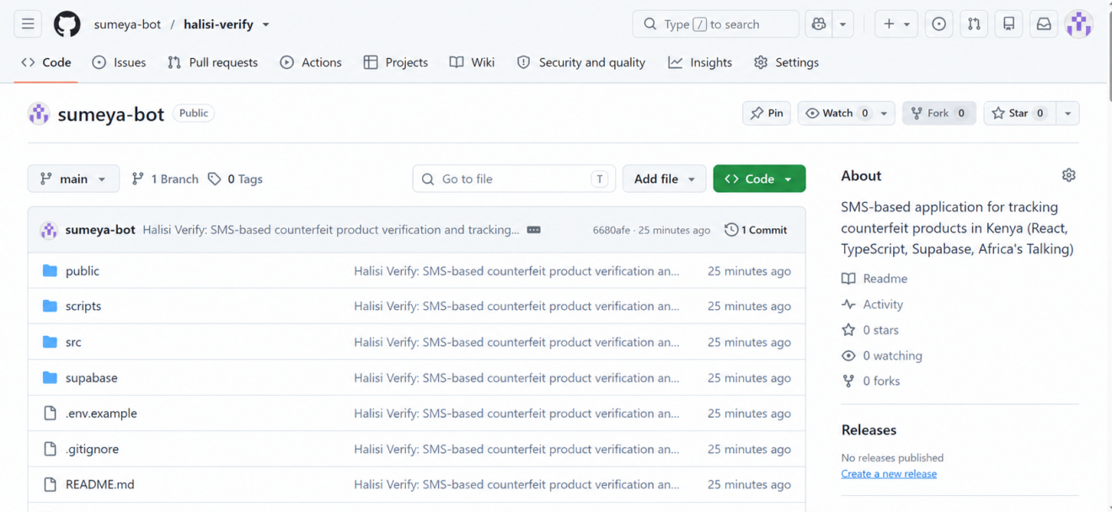
Figure A.1 Project Repository

A.5: Plagiarism Report
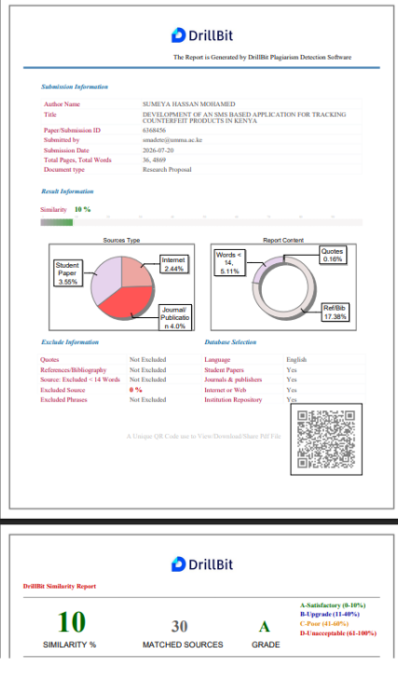
Figure A.2 Plagiarism Report (DrillBit)

REFERENCES
Africa’s Talking. (n.d.). SMS API documentation. https://developers.africastalking.com
Anti-Counterfeit Act, No. 13 of 2008 (Kenya). Laws of Kenya, revised edition 2018. https://new.kenyalaw.org/akn/ke/act/2008/13
Anti-Counterfeit Authority. (n.d.-a). Background. https://www.aca.go.ke/background
Anti-Counterfeit Authority. (n.d.-b). Learn about counterfeits. https://www.aca.go.ke/media-center/61-learn-about-counterfeits
Beck, K., Beedle, M., van Bennekum, A., Cockburn, A., Cunningham, W., Fowler, M., Grenning, J., Highsmith, J., Hunt, A., Jeffries, R., Kern, J., Marick, B., Martin, R. C., Mellor, S., Schwaber, K., Sutherland, J., & Thomas, D. (2001). Manifesto for Agile software development. https://agilemanifesto.org
Booch, G., Rumbaugh, J., & Jacobson, I. (2005). The unified modeling language user guide (2nd ed.). Addison-Wesley.
Braun, V., & Clarke, V. (2006). Using thematic analysis in psychology. Qualitative Research in Psychology, 3(2), 77–101. https://doi.org/10.1191/1478088706qp063oa
Business Daily. (2021, December 9). Taxman banks on mobile verification in fake stamps war. Business Daily Africa. https://www.businessdailyafrica.com/bd/markets/market-news/taxman-banks-mobile-verification-fake-stamps-war-3647516
Capital FM. (2016, September 5). KRA introduces app for verifying excise stamps, products. Capital Business. https://capitalfm.africa/kra-introduces-app-verifying-excise-stamps-products/
Capital FM. (2020, January 10). KEBS seeks to rope in Kenyans in fight against substandard goods. Capital Business. https://capitalfm.africa/kebs-seeks-to-rope-in-kenyans-in-fight-against-substandard-goods/
Center for Intellectual Property x Innovation Policy. (2017, March 17). Innovate4Health: mPedigree battles counterfeit drugs through innovative verification system. George Mason University. https://cip2.gmu.edu/2017/03/17/innovate4health-mpedigree-battles-counterfeit-drugs-through-innovative-verification-system/
Chen, P. P.-S. (1976). The entity-relationship model: Toward a unified view of data. ACM Transactions on Database Systems, 1(1), 9–36. https://doi.org/10.1145/320434.320440
Communications Authority of Kenya. (2025). Fourth quarter sector statistics report for the financial year 2024/2025. https://www.ca.go.ke/sites/default/files/2025-09/Sector%20Statistics%20Report%20Q4%202024-2025_1.pdf
Creswell, J. W., & Plano Clark, V. L. (2018). Designing and conducting mixed methods research (3rd ed.). SAGE.
Elmasri, R., & Navathe, S. B. (2016). Fundamentals of database systems (7th ed.). Pearson.
Engineering for Change. (2024). GoldKeys. Retrieved October 16, 2026, from https://www.engineeringforchange.org/solutions/product/goldkeys
Etikan, I., Musa, S. A., & Alkassim, R. S. (2016). Comparison of convenience sampling and purposive sampling. American Journal of Theoretical and Applied Statistics, 5(1), 1–4. https://doi.org/10.11648/j.ajtas.20160501.11
Fowler, M. (2004). UML distilled: A brief guide to the standard object modeling language (3rd ed.). Addison-Wesley.
Garrett, J. J. (2011). The elements of user experience: User-centered design for the web and beyond (2nd ed.). New Riders.
Kenya Bureau of Standards. (2024). Frequently asked questions: Quality assurance. https://kebs.org/wp-content/uploads/2024/11/FAQs-Quality-Assurance.pdf
Kenya Revenue Authority. (2021). KRA rolls out new generation of excise stamps to fight counterfeits [Press release]. https://www.kra.go.ke/news-center/press-release/1540-kra-rolls-out-new-generation-of-excise-stamps-to-fight-counterfeits
Kenya Revenue Authority. (n.d.). Excise duty. https://www.kra.go.ke/business/companies-partnerships/companies-partnerships-pin-taxes/excise-duty
Lehtonen, M., Ostojic, D., Ilic, A., & Michahelles, F. (2009). Securing RFID systems by detecting tag cloning. In H. Tokuda, M. Beigl, A. Friday, A. J. B. Brush, & Y. Tobe (Eds.), Pervasive computing (Lecture Notes in Computer Science, Vol. 5538, pp. 291–308). Springer. https://doi.org/10.1007/978-3-642-01516-8_20
Mackey, T. K., & Nayyar, G. (2017). A review of existing and emerging digital technologies to combat the global trade in fake medicines. Expert Opinion on Drug Safety, 16(5), 587–602. https://doi.org/10.1080/14740338.2017.1313227
Object Management Group. (2017). OMG Unified Modeling Language (OMG UML), version 2.5.1. https://www.omg.org/spec/UML/2.5.1
Office of the Auditor-General. (2019). Performance audit report on the enforcement of anti-counterfeit regulations by the Anti-Counterfeit Agency. https://www.oagkenya.go.ke/wp-content/uploads/2023/01/Enforcement-of-Anti-Counterfeit-Regulations-2019.pdf
Pressman, R. S., & Maxim, B. R. (2015). Software engineering: A practitioner’s approach (8th ed.). McGraw-Hill Education.
Rasheed, H., Höllein, L., & Holzgrabe, U. (2018). Future information technology tools for fighting substandard and falsified medicines in low- and middle-income countries. Frontiers in Pharmacology, 9, Article 995. https://doi.org/10.3389/fphar.2018.00995
React. (n.d.). React documentation. https://react.dev
Republic of Kenya. (2019). The Data Protection Act, No. 24 of 2019. Government Printer.
Saunders, M., Lewis, P., & Thornhill, A. (2019). Research methods for business students (8th ed.). Pearson.
Sommerville, I. (2016). Software engineering (10th ed.). Pearson.
Staake, T., Thiesse, F., & Fleisch, E. (2009). The emergence of counterfeit trade: A literature review. European Journal of Marketing, 43(3/4), 320–349. https://doi.org/10.1108/03090560910935451
Supabase. (n.d.). Supabase documentation. https://supabase.com/docs
Vercel. (n.d.). Vercel documentation. https://vercel.com/docs
World Economic Forum. (2017). Social entrepreneurship and systems change: Sproxil teaching case. https://www3.weforum.org/docs/WEF_SF17_Case_Studies_05_Sproxil_.pdf

